Explanation of UTEC Mission Profile dialog box columns

The UTEC Mission Profile dialog box is located in the Project Configuration screen. To open the Project Configuration screen, choose Configuration from the Project menu. In the Project Configuration screen, select UTEC MP to display the Mission Profile dialog box.
You will see a list of profiles with their data is displayed.

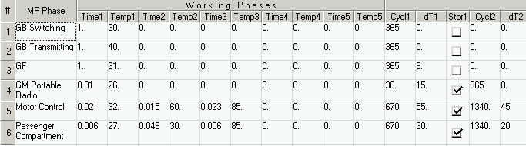

To better understand the data columns explained below, please refer to the UTE C 80-810 document, page 17, “Mission Profile-Parameters necessary to define the mission profile”.

EXPLANATION OF MISSION PROFILE DATA COLUMNS
Part I. Working Phases
Fields | Explanation
Time1, Time2, Time3, Time4, Time5 | annual ratio of times for the PCB, corresponds to τ₁ - τ_{i} in the UTEC document
Temp1,Temp2, Temp3, Temp4, Temp5 | average ambient temperature of the PCB, corresponds to (τ_{ac})₁ - (τ_{ac}) _{i} in the UTEC document

Part II. Thermal Cycling
Fields | Explanation
Cycl1, Cycl2, Cycl3, Cycl4, Cycl5 | annual number of thermal cycles, corresponds to n_{i} in the UTEC document
dT1, dT2, dT3, dT4, dT5 | swing of the thermal variation, corresponds to ΔT_{i} in the UTEC document
Stor1, Stor2, Stor3, Stor4, Stor5 | parameter of corresponding phase i (1 to 5) - corresponds to On or Off for On/Off phase or to Storage or Permanent Working for storage or permanent working phase, refer to UTE C 80-810 document

