Stress/Strength Analysis method
Stress/Strength is a new mechanical reliability analysis method in RAM Commander.
Stress/Strength analysis method determines the probability of failure based on the probability of stress exceeding strength.
Having distributions of Stress and Strength, we may calculate failure probability (Unreliability):
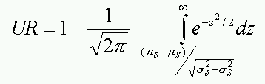
Having variation information between stress and strength (Factor of Safety n and Variations), we may also calculate the unreliability:
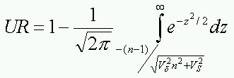
To select this method, change Failure Distribution to “Time-independent” and set Method to “Stress/Strength”:
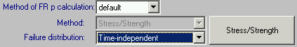

Then press method button, method screen will appear:
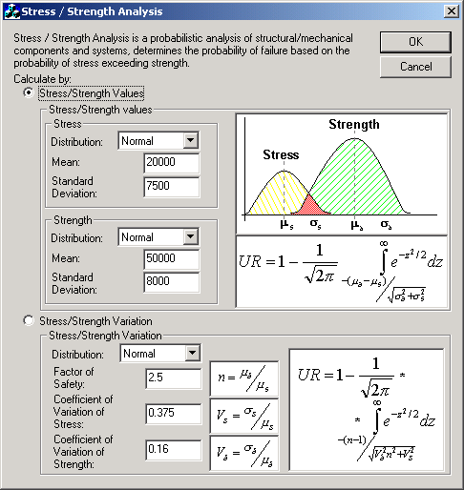

The list of supported distribution combinations is provided below:
Stress distribution | Strength distribution
Exponential | Normal
Normal | Normal
Weibull | Weibull

Enter Stress and Strength data, using either Values data or Variations data. Press Ok. The Unreliability (UR) will be calculated and saved to the item data.

