Mechanical family parts – Item Codes explanation

RAM Commander has 100 different Item Codes of Mechanical components.
RAM Commander supports 2 methods for mechanical item codes reliability prediction – NSWC and NPRD.
For each item code, list of supported methods and a short description is be given.

Accelerometer
NPRD
An instrument for measuring the rate of change of velocity per unit of time.

Accumulator
NSWC, NPRD
An accumulator is a device used to store energy in such applications as:
- fluid supply
- pump delivery pulsation damping
- system pressure surge damping
- leakage and thermal expansion compensation
- emergency and standby power source

Here are typical accumulator designs:
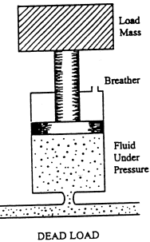

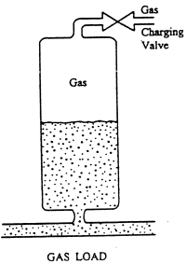
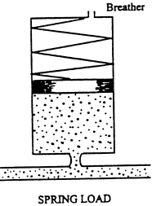

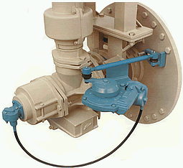
Actuator
NSWC, NPRD
Actuators provide the means to apply mechanical power to systems when and where it is needed. In general, actuators take energy from pumped fluid and convert it to useful work. This conversion is accomplished by using the pumped fluids to generate a differential pressure across a piston, which results in a force and motion being generated. There are two tipes of output motions generated by actuators: linear and rotary.

Air Conditioner
NPRD
Assembly of equipment for the simultaneous control of air temperature, relative humidity, purity, and motion.

Alarm
NPRD
A device that signals the occurrence of some undesirable event.
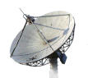
Antenna
NPRD
A conductive structure specifically designed to couple or radiate electromagnetic energy.

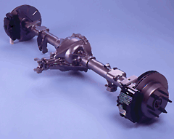
Axle
NPRD
Axle is a shaft on which a wheel rotates.

Battery
NPRD
Battery is a device that produces electricity; may have several primary or secondary cells arranged in parallel or series.
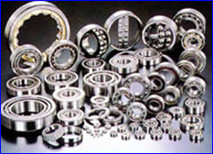
Bearing
NSWC, NPRD
Bearing is a support placed between moving parts to allow them to move easily – see the picture for example.

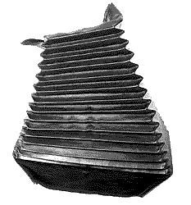
Bellows
NPRD
An instrument, utensil, or machine, which, by alternate expansion and contraction, or by rise and fall of the top, draws in air through a valve and expels it through a tube for various purposes, as blowing fires, ventilating mines, or filling the pipes of an organ with wind.

Belt
NPRD
Belt is an endless loop of flexible material between two rotating shafts or pulleys.

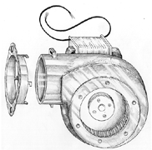
Blower
NPRD
The device in an air conditioner that distributes the filtered air from the return duct over the cooling coil/heat exchanger. This circulated air is cooled/heated and then sent through the supply duct, past dampers, and through supply diffusers to the living/working space.

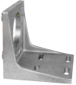
Bracket
NPRD
A wooden or metal mounting device designed to fit in the pinhole of an insulator, and attach it to a (normally) vertical surface such as a pole or the side of a building.

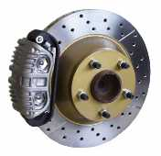
Brake
NSWC, NPRD
Brake is a restraint used to slow or stop a mechanism. Brakes are called upon to convert large amounts of kinetic energy to thermal energy in a very short time. There are numerous brake system types, each with its own parts and reliability characteristics – band brakes, drum brakes, dry and wet disk brakes etc.

Brush
NPRD
A bundle of flexible wires or thin plates of metal, used to conduct an electrical current to or from the commutator of a dynamo, electric motor, or similar apparatus.

Bus Connection
NPRD
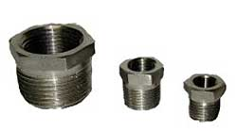
Bus is one of the sets of conductors (wires, PCB tracks or connections in an integrated circuit) connecting the various functional units in a computer. There are busses both within the CPU and connecting it to external memory and peripheral devices. The data bus, address bus and control signals, despite their names, really constitute a single bus since each is useless without the others.

Bushing
NPRD
A cylindrical insulator with external ribs on one end usually mounted on a transformer and used to insulate high voltage leads, or used to reduce frictions.

Cable
NPRD
A conductor for transmitting electrical or optical signals or electric power, a very strong thick rope made of twisted hemp or steel wire.

Cam
NPRD
A rotating disk shaped to convert circular into linear motion.
(a) A turning or sliding piece which, by the shape of its periphery or face, or a groove in its surface, imparts variable or intermittent motion to, or receives such motion from, a rod, lever, or block brought into sliding or rolling contact with it.
(b) A curved wedge, movable about an axis, used for forcing or clamping two pieces together.
(c) A projecting part of a wheel or other moving piece so shaped as to give alternate or variable motion to another piece against which it acts.

Camera
NPRD
Device for recording visual range on film.

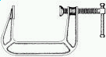
Clamp
NPRD
An instrument with a screw or screws by which work is held in its place or two parts are temporarily held together.

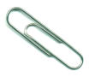
Clip
NPRD
An embracing strap for holding parts together.

Clutch
NSWC, NPRD
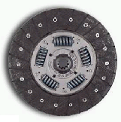
The principal function of a friction clutches is to convert kinetic energy to heat and then either to absorb or otherwise dissipate the heat while simultaneously, through friction, reducing the relative movement between the friction material and the part to which it is engaged. Clutches are made up of two basic components – the pressure plate and disc.

Compressor
NPRD
The compressor is part of a propulsion system used to squeeze the air, or to increase the pressure of the air flow.

Computer peripheral
NPRD
Computer peripherial devices.

Contact
NPRD
A junction where things (as two electrical conductors) touch or are in physical contact.

Connector Accessory
NPRD

Cord
NPRD
A string, or small rope, composed of several strands twisted together.

Counter & Timer
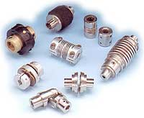
NPRD

Coupling
NSWC, NPRD
A coupling is a device which makes a semi-permanent connection between two shafts.

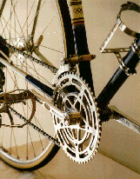
Crank
NSWC, NPRD
Crank is a bent portion of an axle, or shaft, or an arm keyed at right angles to the end of a shaft, by which motion is imparted to or received from it; also used to change circular into reciprocating motion, or reciprocating into circular motion.

Detector
NPRD

Drive
NPRD
A mechanism by which force or power is transmitted in a machine, a device that writes data onto or reads data from a storage medium.

Drum
NPRD
A bulging cylindrical shape; hollow with flat ends.

Duct
NPRD
A pipe, tube or channel that conveys a substance (such as warm or cold air throughout a building).
Engine
NPRD
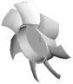
Fan
NPRD
A device for creating a current of air by movement of a surface or surfaces.

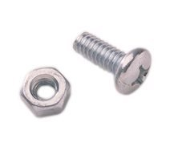

Fasteners
NSWC, NPRD
Fastener is a restraint that attaches to something or holds something in place. Bolts, screws, studs are all examples of fasteners.

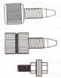
Fitting
NPRD
Fitting consisting of threaded pieces of pipe for joining pipes together.

Gasket
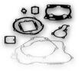
NPRD
A liner applied between the sealing surface of container lip and closure. A gasket provides the ultimate seal.

Gauge
NPRD
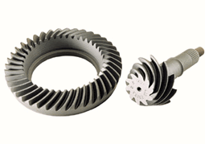
A measuring instrument for measuring and indicating a quantity such as the thickness of wire or the amount of rain etc.

Gear
NSWC, NPRD
Gear is a toothed wheel that engages another toothed mechanism in order to change the speed or direction of transmitted motion.

Generator
NPRD
A machine that converts mechanical energy into electrical energy.

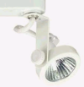
Gimbal
NPRD
Contrivance for permitting a body to incline freely in all directions, or for suspending anything, as a barometer, ship's compass, chronometer, etc., so that it will remain plumb, or level, when its support is tipped, as by the rolling of a ship. It consists of a ring in which the body can turn on an axis through a diameter of the ring, while the ring itself is so pivoted to its support that it can turn about a diameter at right angles to the first.

Gyros
NPRD
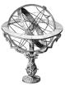
A rotating wheel inside a frame that lets its axis turn in any direction. When the wheel is spinning, it is able to maintain the same absolute direction in space.

Gyroscope
NPRD
A rotating wheel inside a frame that lets its axis turn in any direction. When the wheel is spinning, it is able to maintain the same absolute direction in space.

Heat exchangers
NPRD

Heater
NPRD
A fossil-fueled, electric or solar device used to heat the water or air.

Hose
NPRD
A flexible pipe for conveying a liquid or gas
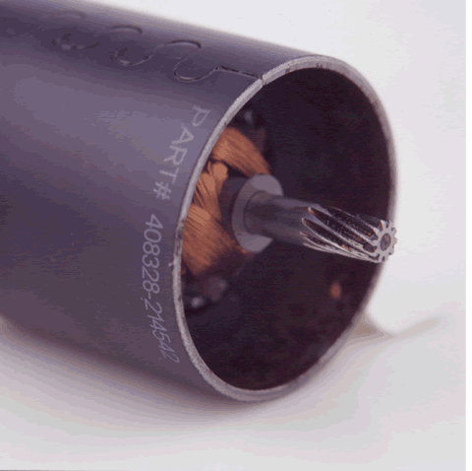
Housing
NSWC, NPRD
Housing is a protective cover designed to contain or support a mechanical component.

Igniter
NPRD
A device for lighting or igniting fuel or charges or fires.
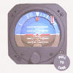
Indicator
NPRD
A device for showing the operating condition of some system

Instrument
NPRD
A device that requires skill for proper use

Insulator
NPRD
Any material that does not conduct electricity. Glass and rubber are common insulators. These materials are made of atoms which don't allow electrons to move freely, which means there can be no electric current.

Intercomm
NPRD
An intercom allows you to call another system phone without using an outside line. You can also use it to transfer outside calls to a co-worker by using the transfer button. Each phone in the key system is assigned and intercom or extension number which is usually three digit long.

Joystick
NPRD
A joystick is a physical device typically used to control objects on a computer screen. It is frequently used for games and sometimes used in place of a mouse.

Keyboard
NPRD
Device consisting of a number of mechanical buttons (keys) which the user presses to input characters to a computer.

Knob
NPRD
Small cylindrical insulator used to secure house wiring or the cylindrical member projecting out from the insulator body for tying the line wire.

Lens
NPRD
A transparent, biconvex, nearly spherical body in the eye which focuses light passing through the pupil (images) onto the retina.

Light
NPRD

Loudspeaker
NPRD
An electro-acoustic transducer that converts electrical audio signals at its input to audible sound waves at its output.

Magnet
NPRD
A device which has the ability to attract or repel pieces of iron or other magnetic material. Speaker magnets provide a stationary magnetic field so that when the coil produces magnetic energy, it is either repelled or attracted by the stationary magnet
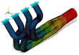
Manifold
NPRD
A pipe that has several lateral outlets to or from other pipes

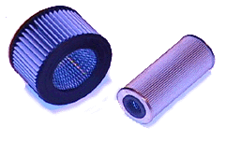

Mechanical filter
NSWC, NPRD
Filter is a device that removes something from whatever passes through it. Filters are constructed of a porous media through which fluid is passed.

Miscellaneous
NPRD

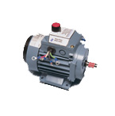
Module
NPRD

Motor
NSWC, NPRD
Electrical motor is a device or machine that converts electricity (AC or DC) into mechanical energy.
Motor in general is a machine that converts other forms of energy into mechanical energy and so imparts motion.

Mount
NPRD
Mounting consisting of a piece of metal (as in a ring or other jewelry) that holds another part in place
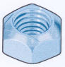
Nut
NPRD
A small square or hexagonal metal block with internal screw thread to be fitted onto a bolt.

Optical
NPRD

Panel
NPRD

Pin mechanical
NPRD

Power Supply
NPRD

Power Transmitter
NPRD

Printer
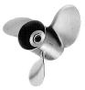
NPRD
An output device that prints the results of data processing

Propeller
NPRD
A mechanical device that rotates to push against air or water.

Pulley
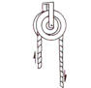
NPRD
A simple machine consisting of a wheel with a groove in which a rope can run to change the direction or point of application of a force applied to the rope.

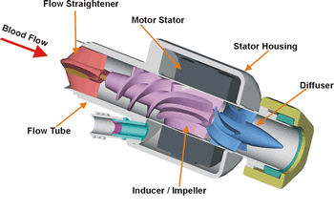
Pump
NSWC, NPRD
Pump is a mechanical device that moves fluid or gas by pressure or suction. Pumps are devided into two general classes – centrifugal and displacement.

Recorder
NPRD
equipment for making records

Regulator
NPRD
any of various controls or devices for regulating or controlling fluid flow, pressure, temperature, etc.
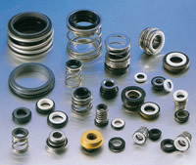
Seal
NSWC, NPRD
A seal is a device placed between two surfaces to restrict the flow of fluid from one region to another. Seals are required for both static and dinamic applications.

Sensor
NPRD
any device that receives a signal or stimulus (as heat or pressure or light or motion etc.) and responds to it .

Separator
NPRD
An apparatus that uses centrifugal force to separate particles from a suspension.

Servo
NPRD
Control system that converts a small mechanical motion into one requiring much greater power; may include a negative feedback system

Shaft
NPRD
A revolving rod that transmits power or motion, a line that forms the length of an arrow pointer, a long rod or pole.

Shock absorber
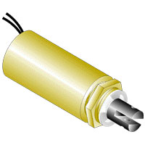
NPRD
A mechanical damper; absorbs energy of sudden impulses

Solenoid
NSWC, NPRD
Solenoid is a coil of insulated or enameled wire wound on a rod-shaped form made of solid iron, solid steel, or powdered iron. Devices of this kind can be used as electromagnets, as inductors in electronic circuits, and as miniature wireless receiving antennas.
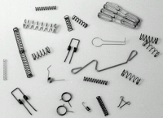
Spring
NSWC, NPRD
Spring is a metal elastic device that returns to its shape or position when pushed or pulled or pressed.

Sprocket
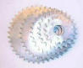
NPRD
Roller that has teeth on the rims to pull film or paper through;
Thin wheel with teeth that engage with a chain;
Tooth on the rim of gear wheel.
A toothed wheel or gear that is part of a chain drive. The front sprockets are also commonly called chainwheels or chainrings. The term "sprocket" is perfectly correct to refer to either front or rear, but use most adult cyclists use this term mainly to refer to the rear sprockets. The use of "sprocket" to refer specifically to a chainwheel is mainly confined to BMX usage. The rear sprockets individually are also commonly called cogs or gears; as a group they are referred to as a block, cassette, cluster or freewheel.

Starter
NPRD
An electric motor for starting an engine, a hand tool consisting of a rotating shaft with parallel handle.

Synchro
NPRD
A motor like device containing a rotor and a stator and capable of converting an angular position into an electrical signal, or an electrical signal into an angular position. When several synchros are correctly connected, all of the rotors will align themselves in the same angular position. This is useful, since one synchro whose angular position is forced to change, can drive another synchro to indicate the angular change.

Tank
NPRD
Large (usually metallic) vessel for holding gases or liquids

Telescope
NPRD
Capable of being extended or compacted, like a telescope, by the sliding of joints or parts one within the other;

Terminal Connection
NPRD

Transducer
NPRD
an electrical device that converts one form of energy into another; A device for converting sound, temperature, pressure, light or other signals to or from an electronic signal.

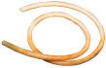
Tubing
NPRD
Conduit consisting of a long hollow object (usually cylindrical) used to hold and conduct liquids or gases

Valve
NSWC, NPRD
Valve is a control consisting of a mechanical device for controlling the flow of a fluid. The picture below shows a typical valve mechanism.
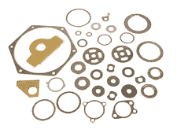
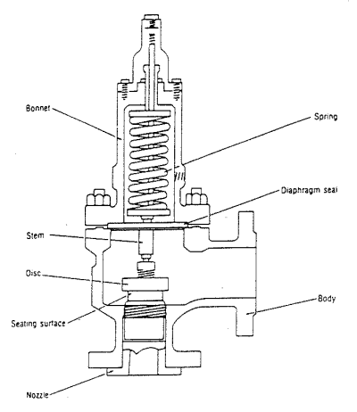

Washer
NPRD
Seal consisting of a flat disk placed to prevent leakage

Monitor
NPRD
display consisting of a device that takes signals from a computer and displays them on a CRT screen

