RAM Commander Installation and Run – Troubleshooting

Problem: RAM Commander user can’t access network drive with projects sometimes ("Fatal error"), when other user(s) are already working with it. If nobody else is working with drive user may access it.
Additional sympthoms: Network drive is shared with full access rights. If user is first on the drive he enters successfully. May appear sporadically (depending on the first user who access the network drive). For some user combinations may work, for some user combinations may not work.
Reason:
Second user connectng to the network drive will try to use Pervasive Database Engine of the first user connected to the drive. It will search second user PC and try to access Pervasive Database Engine network service. If second user can’t find other user PC (DNS, sub-net, VPN etc.) or can’t access other user's Pervasive Engine (Firewall) then the connection attempt will fail.
Solution:
- Check and ensure that all RAM Commander users may "ping" each other computers by computer name.
- Check and ensure that Pervasive Database Engine is included into the list of exceptions on all RAM Commander user computers and that Firewall exceptions are not disabled.
Pervasive Database Engine is usually added to the Firewall exceptions list when RAM Commander is installed. Setup procedure gives Windows Firewall Unblock question:
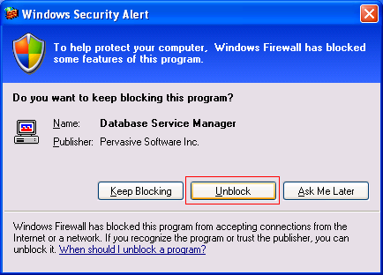 | 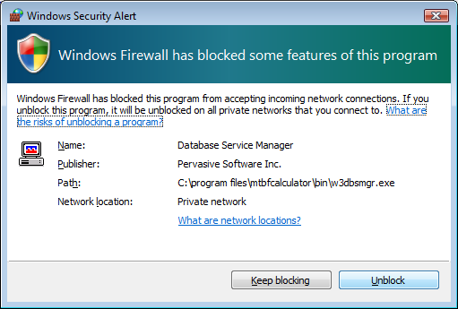

If user answers yes, Pervasive Engine is added to the exceptions list.
For all RAM Commander user computers, perform steps described below:

To check that the Pervasive Database Engine is allowed by Windows Firewall:
- Open Control Panel from Start menu, Settings section.
- Open "Windows Firewall"
- If Firewall is off, no need to continue, you may close the Firewall dialog.
- If Firewall is on, make sure that "Don't allow exceptions" check box is empty:
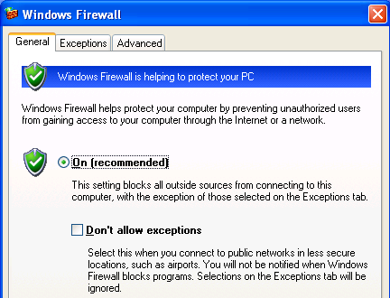
- Switch to "Exceptions" tab of the dialog.
- Make sure that there is "Database Service Manager" program in the list:
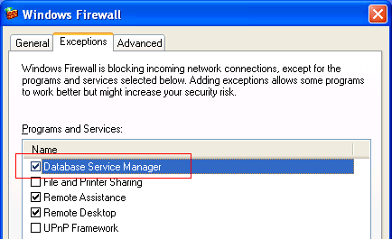
- If there is no "Database Service Manager", click "Add program" button, then click "Browse" and select W3dbsmngr.exe program in RAM Commander working folder (usually RAMC32\BIN). Then press Ok. "Database Service Manager" should now appear in the list of exceptions.
- Press Ok on the Firewall dialog to close it and store changes.

Problem: during or after the installation the error messages appears: “Oper=<11>” “Microkernel error = 11 The specified pre-imaging filename is invalid”
Solution:
The problem is Novell Client v4.91 SP2. Novell accepts this problem and provides a fix.
See the article in Novell Support database for more information: http://support.novell.com/cgi-bin/search/searchtid.cgi?10100441.htm
Use this link to download the Novell patch: http://www.novell.com/support/search.do?cmd=displayKC&docType=kc&externalId=InfoDocument-2974113&sliceId=&dialogID=42935816&stateId=0%200%2042943684
We suggest that only experienced network addministrator should install this update.

Problem: during the network installation – after 61% of installation, message appears: “Component transfer error: File *.rra”
Solution:
1. Run the installation, and make sure that the option Hasp Drive (see the picture) is UNCHECKED exactly as it is on the picture:
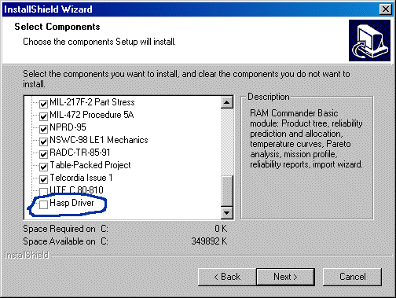
2. Finish the installation of RAM Commander, but do not run it.
3. From the RAM Commander program group in the Start menu, choose and run program “HDD32”. It will install HASP driver. (installation is described in RAM Commander installation guide).

Problem: Error message with code “3105” after starting RAM Commander
Solution: Problem has already been solved, starting from RAM Commander installation v7.1.
If problem persists and you are using Windows NT/2000, create folders C:\WINNT\MKDE and C:\WINNT\MKDE\LOG. (this folders must be created automatically by 7.1 installation).

Problem: The PC used as a network plug server has Windows 95 operating system, and plug driver should be started manually after server reboot
Solution: On the server, copy NHSRVW32.EXE to the SYSTEM directory in the Windows root directory (c:\WINDOWS\SYSTEM).
Create NHSRVW32.EXE shortcut in the Startup group of the Start menu. (Open Windows Explorer, find and select c:\WINDOWS\SYSTEM\NHSRVW32.EXE file. Right-click on Start button, choose Explore, open folder Programs, then subfolder Startup. Drag&Drop c:\WINDOWS\SYSTEM\NHSRVW32.EXE file to StartUp folder.)
Restart the computer. Now you may remove insalation CD from server, and HASP manager should start automatically after login to windows (please note - not after server OS loading, as in WinNT, but after successful user login).

Problem: “HASP Plug can’t be found” on Windows 2000, XP
Installation is completed, but RAM Commander can’t be started and gives error message about Local and Network Plugs.
Solution:
You should install new HASP plug drivers. If you have our installation CD, open folder “\HASP\Driver Ver. 4.99" and start file HDD32.EXE. Install the driver for Parralel port and reboot your computer. If you have no CD, please ask your RAM Commander suppliers for the new plug driver version 4.99.
If 4.99 version driver does not help, please try to install HASPUserSetup.exe driver from the installation CD “\HASP\Driver HL” folder.

Problem: “HASP Plug can’t be found” in segmented network / VLAN
Solution:
License Manager developers give the following solution:
a) There is a file nethasp.ini.
b) Place this file to RAMC32\BIN folder.
c) Open this file with Notepad.
d) Find section [NH_TCPIP] (line 96), find key NH_SERVER_ADDR = 111.111.111.111,
e) modify its value to the License server's IP address, for example NH_SERVER_ADDR = 192.114.176.65
f) save the file
RAM Commander should be able to find the plug.

There could be some more surprises in the network:

The server has more than 1 network adapter
If after steps from a) to f) you still have the same message about "plug not found", and you have a possibility that some computers are connected through other network adapter, do the following:

g) There is a file nhsrv.ini.
h) On the server, place this file to license manager folder, where the executable is.
i) Open this file with Notepad.
j) Find section [NHS_SERVER] (line 12), find key NHS_ADAPTER_IP, remove ";" comment sign from the left site, and write network adapter data like is shown in comments (<IpAddr-SubMask> [, <IpAddr-SubMask> ...]). Network administrator should assist you.
k) save the file
l) reboot the server

If after steps from a) to l) you still have the same message about "plug not found", there could be problems with server ports.
You should consult the network administrator about specific ports.
In the file nethasp.ini there are key NH_PORT_NUMBER (exactly after the key NH_SERVER_ADDR we modified in paragraph 3). Remove ";;" from the left side and set the TCP/IP port number. This is optional. The default number is 475.

Problem: Error message with code “1022” or “1032” after starting RAM Commander
Solution: Problem could appear on Windows 95/98 on RAM Commander workstation. Do the following:
- Press Start button
- Choose Run
- Type regedit and press ok
- Open HKEY_LOCAL_MACHINE group, then Software, Pervasive Software, Microkernel Router, Version 7, Settings
- Double click on “Target Engine” key in the right part of the window.
- Change key value to “0”
- Press Ok.

Problem: Error message with code “8020” after starting RAM Commander
Solution:
In client-server configuration, can appear on client if connection with the server was terminated.
User should ensure the server is on, the connection is established (network drive etc.), and reboot the workstation.

Problem: RAM Commander can’t be completely uninstalled
Solution:
If you want to reinstall RAM Commander, we recommend to uninstall it (with the help of Windows Add/Remove Programs dialog from Control Panel or with the help of RAM Commander installation) and then install it. There could be a problem, when after uninstalling software, installation program gives you option to Remove RAM Commander once more. If you choose option remove, finish removing and start installation once more – you get Modify/Remove option again. To remove the problem:
- Uninstall RAM Commander,
- Enter registry (from Start menu, choose Run, type "regedit", choose Ok.
- Go by the path:
HKEY_LOCAL_MACHINE
Software
Microsoft
Windows
CurrentVersion
Uninstall
- Choose "Uninstall", press right mouse key, choose "Find'
- Enter "RAM Commander" and press Enter.
- Program will find and show you one line in the right part of the screen. Press TAB, cursor will move to the left part of the screen. Press Del, confirm "Yes".
When you start RAM Commander installation again, it will not offer you Modify/Remove option again, but will offer to install RAM Commander – perform the usual installation steps.

Problem: Error message “W3DBSMGR: Error 8509: Timeout occured during the initialization of MKDE” or error message with code “3012” inside it
Solution:
The most common reason of the problem – absence or old version of Microsoft dll files \WINDOWS\SYSTEM\MSVCP60.DLL and \WINDOWS\SYSTEM\MSVCRT.DLL. Both files must be present and their creation year must be later then 1998. If you need the files – contact our support service or take them from other computer with the same operating system.

Problem: Error 1021
Sometimes happen because there is not enough free space on the system disk (disk where Windows installed) or insufficient access rights to database files.
Solution:
Free some disk space and try once more.
Make sure that user has full access rights to RAM Commander installation folder (by default C:\RAMC32\)and all it’s subfolders and files on all levels.

Problem: Error message “The setup routines for the Microsoft Access Driver {*.mdb} could not be loaded due to system error code 126.”
Solution:
See Microsoft KB article:
http://support.microsoft.com/default.aspx?scid=kb;EN-US;q260558
There are two possible causes for this problem:
• | Incorrect registry settings for MDAC components.
• | Incompatible .dll files.
These problems may have arisen because of an installation of older software that changed the registry settings of the ODBC drivers or replaced some .dll files with incompatible versions.

Resolution for incorrect registry settings problem:
1. | Start Registry Editor (Regedt32.exe).
2. | Locate the following key in the registry:  HKEY_LOCAL_MACHINE\SOFTWARE\ODBC\ODBCINST.INI  Installation information for ODBC drivers is stored in this key. Make sure that all the required ODBC driver files are in the correct folder as described by the registry keys. For example, assume that you have the following information in your registry for the Microsoft Access ODBC driver:  HKEY_LOCAL_MACHINE\SOFTWARE\ODBC\ODBCINST.INI\Microsoft Access Driver (*.mdb)  Driver = C:\WINNT\System\Odbcjt32.dll  Setup = C:\WINNT\System\Odbcjt32.dll  This will cause an error if the Odbcjt32.dll file is in the C:\WINNT\System32 folder. You can modify the registry key values to C:\WINNT\System32\odbcjt32.dll to solve this problem. Also verify that the Odbcinst.ini file has the correct entries in the same way.  Any wrong value in HKEY_LOCAL_MACHINE\SOFTWARE\ODBC\ODBCINST.INI under the Setup key will cause this error.

Resolution for incompatible .dll files problem:
Reinstall your current version of MDAC, or install the latest version. See the "References" section of this article for more information on reconfiguring an MDAC installation. The latest version of MDAC can be downloaded from the following Microsoft Web site:
http://msdn.microsoft.com/dataaccess

Problem: RAM Commander works fine for user with PC administrator access rights, but does not work for another user.
Solution:
The reason is insufficient user rights to access system resources required for RAM Commander.
Grant full access rights to the user for the following resources:
Folders:
RAM Commander installation folder (usually C:\RAMC32)
Project folders on all local and network drives where user wishes to store his projects
Registry branches:
HKEY_LOCAL_MACHINE\SOFTWARE\Advanced Logistics Developments
HKEY_LOCAL_MACHINE\SOFTWARE\Pervasive Software

How to report about troubles with RAM Commander
If all these advices did not help you and you still have problems with RAM Commander, please run ConfRep.exe program, located in RAMC32\BIN folder (and in ALD Engineering group in Start menu). The program generates file “RAMC32\BIN\ramcconf.txt”, containing information about system parameters and RAM Commander parameters. Please send this file to RAM Commander support team with precise specification of your problems and error messages. If you use client-server configuration, perform these operation on both client and server computers and send both files “ramcconf.txt” to us.

