RAM Commander FAQ
(Frequently asked questions and answers)

General software-related QA

Q: What are RAM Commander software system requirements?
A: RAM Commander System Requirements:
- 400 MHz Intel Pentium processor
- Windows 98 SE, Windows Me, Windows NT4 SP3(at least), Windows 2000, Windows XP SP2
- 128 MB of free available system RAM (256 MB recommended)
- 200 MB of available disk space
- display resolution 800 x 600 or better

Q: How can I check which version of RAM Commander I use?
A: Go to the RAMC32\BIN folder, and run the confrep.exe program – it will show you the version and will generate the file ramcconf.txt – RAMC configuration data file. You can send the file to us if you have to report some problem with the RAMC (we have to know you version and configuration to help you).

Q: I run RAM Commander, log in and get the message:
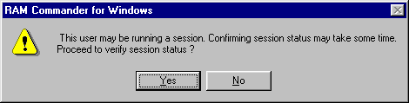
What should I do?
A: Please check – may be RAM Commander is already running, and you are trying to run it twice. If not – run the User manager from RAM Commander program group in Start menu, select your user name and press “Free user” button. Press Yes and close the window. Now try to run RAM Commander again.

Q: In all reports, the amount of text in columns is much smaller then the column width – may I adjust the width?
A: Yes. Go to RAMC32/BIN folder, find file named <your user name>.INR, open it in Notepad, find [General] section and add parameter TWIPS_PER_INCH=1440 . Decrease the number (default value 1440) if you want to decrease all columns width (try values between 1000 and 1200, depending on font used).

Q: May I change the size of report columns?
A: Yes. Go to Reports menu, choose Setup, Choose “Columns”. Then you may choose report name ans set up column’s sizes for the report. Size 0 means that column will not appear in the report.

Q: All reports look wrong – thay have a lot of pages with only header on each page. How can I fix it?
A: You should have properly installed default printer. Please check that you have default system printer driver properly installed, or install it and make it default.

Q: How can I change the names of Maintenance levels (like Organizational, Intermediate, Depot etc)?
A: Open project, choose menu item “Project”, then “Configuration”. Press button “Maintenance levels” to the right of “Maintainability” choice. Change level names and press Ok.

Q: What is the best way to perform analysis at different operating modes?
A: You may switch the current project to another analysis mode, by clicking the icons "Operating", "Non-operating", "Derating", etc which are located to the left of the product tree. Then you may use function "Translate". It works in a following way:
1. You create project, fill data, fill reliability data (operating or non-operating).
2. Calculate.
3. if you wish to calculate the project in another mode than it was created, you switch to another mode (by clicking the icons "Operating", "Non-operating", "Derating", etc which are located to the left of the product tree)
4. Then you should translate reliability data from previous mode to current mode. Choose item "Translate" from the Project Manu, choose source and destination data (for example, if you have already entered reliability data in operating mode and switched to non-operating, choose Source=Operating and Destination=Non-operating. Press Ok.
5. You may continue to work with project in both modes - switching between them as described above.
6. Please note, that if you wish to work with project in both Oper. and Non-oper. modes, the recommended sequence is to create project in Operating mode and fill all reliability data on method screens first, and then switch to Non-operating - because Operating methods contain more data and are newer than non-operating.

Q: In RBD module, in the MTBCF graph, text display is corrupted – what to do?
A: Your default system font is not suitable for the graph. Please do the following: create file “font.dat” in your RAMC32\BIN folder, and write “ARIAL” inside the file. If it does not help, try to change “ARIAL” to “MIRIAM” or “COURIER” – it should solve the problem. The file could be created with the help of Notepad in Start-Programs-Accessories menu of MS Windows.

Q: Could you explain better “Network software version” and ”Network plug” meaning and the difference between network and local?
A: Network version of the software (client/server) means, that the software is situated on the server, and the clients run it from the server on their computers (in standalone version, software is situated on each computer).
Network security plug means that there is only on security plug in the network, and each client computer looks for this plug, and license count is controlled by the plug server (in the standalone security plug, each computer has it's own plug).
These two subsystems are really independent - network software version may work with local plugs, and standalone software installations may work with network security plug.
In case of network security plug, total amount of currently logged-in users is maintained on the server and is limited by user’s license type. There is no limitation for the count of software installations, the limit is for the count of simultaneously working users.

Q: I have your Global Component Library. It contains only IC active elements. Where are resistors, capacitors and other passive elements?
A: ALD supplies the library containing thousands of widely used active parts by the world leading manufacturers continually updated by RAM Commander team adding more manufacturer’s data on a monthly basis. RAM Commander user is able to add new elements to this library and update it.
ALD supplies only active components. The number of different passive elements is so high that we use another strategy for passive elemtents - The Part Name recognition algorithms:
Leading manufacturers are using special algorithms naming their parts. RAM Commander implements these algorithms for the opposite direction in order to get reliability data from Part Name.
This works like the component library - the only difference is that component data are not stored in the actual library, but are defined by Part Name decomposition and analysis according to a manufacturer's algorithm. To use the feature, you need to provide manufacturer's name.
This strategy is much more powerful than the component library because it covers a huge amount of parts, even parts which do not exist at the current moment - if the manufacturer uses the same naming algorithm its new parts will be recognized by our sofware.
RAM Commander supports algorithms for encoding Part Numbers of Resistors and Capacitors of the following manufacturers:
AVX, ATC, Bourns, Cal-chip, DALE, Hitano, Garrett, IRC, Johanson, Kemet, KOA, Kyocera, Mallory, Meritek, Murata, MSI, NIC, Nichicon, Novacap, Samsung, Siemens, Syfer, OhmCraft, Paccom, Philips, Phycomp, Ralec, ROEDERST, TDK, TaiyoYuden, Vishay, Roedenstein, Vitramon, Yageo.

Please see the following example of using this recognition and Quick Create option:
1. In the Product Tree, from the Tree menu, choose Quick Create. Fill in information about the component – Generic name (GN) for search in the Component Library, Part Name (PN) and Manufacturer for use of recognition algorithm etc.:
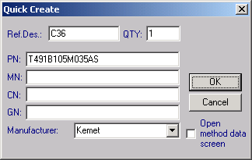
2. Check the <Open method data screen> check box for checking and editing of the component data before inserting it into the tree, or leave it unchecked if you wish to create the component without additional editing. Press ok.
3. If the component is found in the Library or recognized, it will be added to the Tree.

Reliability-related QA

Q: Hybrid component in prediction methods GJB299 ,MIL 217-1 ,MIL 217-2 – how should we use it?
A: For methods GJB299 ,MIL 217-1 ,MIL 217-2 user have to define Hybrid in the following way:
1. Create Item in the product tree Family: Electronic, Item Code: Hybrid
(no special data needed on the method screen - this screen doesn't exists)
2. Under Hybrid create Substrate (Family: Electronic, Item Code: Substrate) and on the method specific screen enter all information.
Note: under one Hybrid user may create more then one Substrate
3. Under Substrate add all components placed on this substrate.

Q: With the prediction method 'MIL-217-F Notice2', how to deal with the hybrid components which CHIP ATTACH is composed of Solder and Epoxy(Conductive)?
A: 'MIL-217-F Notice2' method doesn't support such chips, composed of different components. We are developers of the software, not developers of the standard. So the best answer you may get by analyzing the standard and deciding by yourself how to implement it for your case.
Our advice is to use "worst case" methodology and enter that the chip attach is "Epoxy(Conductive)", which will give worst reliability result, comparing with "Solder".

Q: In the RBD analysis, MTBCF calculation: how to give the value Max Time and step or Epsilon and step?
A: Mean time between critical failures (MTBCF) is the mean time until the function defined by the RBD diagram fails. RAM Commander uses numeric integration of the reliability function R(t):
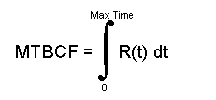
The Max Time is an upper limit of integration.
With the help of changing the Max. Time you reach the result – when you reach a certain Max. time when the function almost reaches 0 and MTBCF stops changing. This means that you can ignore the “tail” of the graph:
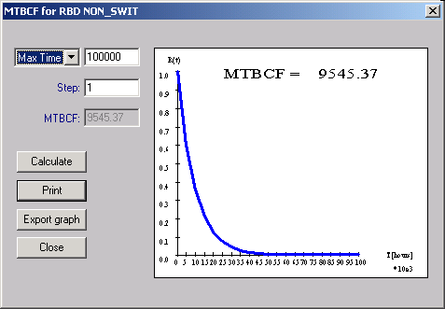

The general rule is to start with the Max. time which is about 10 times of the expected MTBF and the Step 100 times less than the Max .time. You just match the Max. time and Step. When after some tries you get necessary Max.Time, you may reduce the Step to get more accuracy.
If you choose Epsilon option, set Epsilon to the minimal MTBCF value where you want to stop the R(t) integration – on the graph the Epsilon is a distance between T axe
and graph, where you are satisfied with the preciseness of the result and want to
stop calculations.
Larger Max Time, smaller epsilon, and smaller integration steps lead to better results yet longer computation times:
a) if you choose short Max Time and large step, the function integration may be presented as squares area calculation:
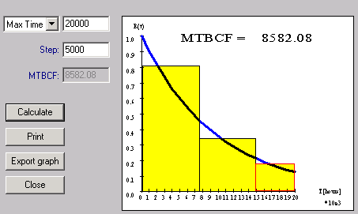

if you choose large Max Time and small steps, the function integration may be presented as squares area calculation:
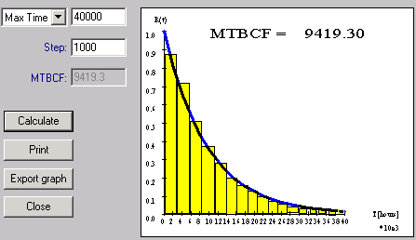
So you may see how the parameters you enter influence the calculation process.

Q: What is a field “Field factor”?
A: It is a field multiplicative factor, you may use it to affect calculated FR.
For example, if from your experience you know that MIL217 gives FR prediction which really in practice appears to be too high, and real values are 30% lower than predicted, you may set field factor to 0.7:
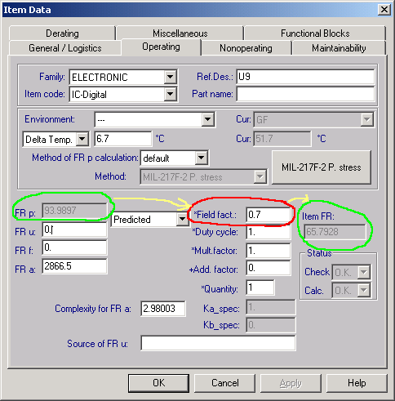

FMECA

Q: How does RAM Commander determine the Criticality Number Thresholds in the Criticality Matrix?
A: There are Criticality groups in the FMECA library:
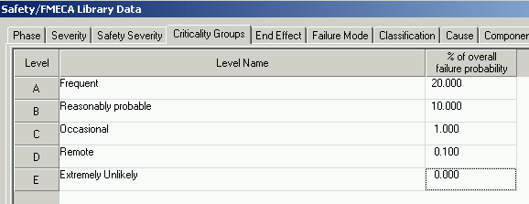
Using these Criticality Groups data, RAM Commander offers you calculated Criticality Treshold for each group during the report generation:
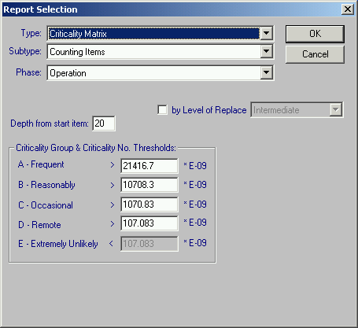
Criticality Number Thresholds for group X = <FR of currently selected tree item> * <probability of occurrence of Criticality Group X from FMECA Library>.
User may manually change these tresholds before the report.

