RAM Commander – Network License installation

- Choose License server PC
When working in a network environment, select a computer to act as the “plug server”. The red plug must always be attached to this computer so that users can access RAM Commander. (The plug server does not need to be the application server - any other server or workstation will do. The only requirement is that this PC must be switched on whenever someone is using RAM Commander, and accessible through local network).

- License Server installation
Insert Network (Red) Plug to parallel or USB port of the license server computer.
Run NetHASP License Manager setup utility: insert RAM Commander installation CD, double-click on file \HASP\Servers ver. 8.31\lmsetup.exe.
Choose option to install it as Windows NT service - see the picture below:
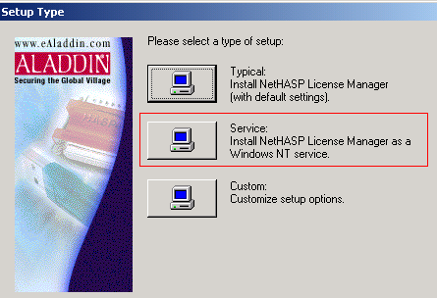

After the successful installation, License manager service will be installed and started automatically. RAM Commander users may run their software using network plug.

- Client computers installation
- During the client application installation answer “Yes” when asked about hardware plug connection.
- If the client application doesn’t work or if during the installation “No” option was selected in the plug question, install the plug driver manually:
Insert RAM Commander installation CD, double-click on file \HASP\Driver HL\ HASPUserSetup.exe, and proceed with the installation.

- Plug Status Monitoring (optional)
If there is a need to monitor real-time plug status (how many active users connected, who exactly is connected etc.) the Plug Monitor software may be installed – run the setup from RAM Commander installation CD: HASP\MONITOR\AKSMON32.EXE

Troubleshooting

Problem: Can’t find HASP Plug in segmented network/VLAN
Solution: We recommend the Network administrator assisting you in
all aspects of the HASP plug problems.
License Manager developers suggest the following solution:
1. Browse to locate the nethasp.ini file on the Installation CD (folder HASP\Servers ver. 8.31\).
2. Copy it to the RAMC32\BIN folder on client computer.
3. Open this file in Notepad.
4. Locate NHSERVER ADDR=111.111.111.111 in
the [NH TCPIP] section (line 96).
5. Edit the License Server’s IP address (for example:
NHSERVER ADDR=192.114.176.65).
6. Check and change other network parameters in the [NH TCPIP] section.
7. Save the file.

The following are solutions to other complications that may arise in
the network.

Use TCPI/IP Broadcast mechanism is prohibited
Open the nethasp.ini file, set NH_USE_BROADCAST = Disabled.

The server has more than 1 network adapter
If you have completed the above steps and you still receive the same error message (“plug not found”), some of the network computers may be connected with another network adapter.
Do the following to solve the problem:
1 Browse to locate the nhsrv.ini file on the Installation CD, folder HASP\ Servers ver. 8.31\.
2 Copy it to the License Manager folder on the server.
3 Open this file in Notepad.
4 Locate NHS ADAPTER IP in the [NHS SERVER] section (line 12).
5 Delete “:” comment sign from the left site and type the correct network adapter data as shown in the comments ((<IpAddr-SubMask> [, <IpAddr-SubMask> ...]).
6 Save the file.
7 Reboot your computer.

If you have completed the above steps and you still receive the same error message (“plug not found”), there could be problems with the server ports.
Do the following to solve the problem:
1. Consult the Network administrator about specific ports.
2. Open the nethasp.ini file in Notepad.
3. Locate NH PORT NUMBER in the [NHS SERVER] section (the line after NH SERVER
ADDR).
4. Delete “:” comment sign from the left site and type the TCP/IP port number. This is optional. The default number is 475.
5. Save the file.
6. Reboot your computer.

