Using PSPICE and importing it’s data to RAM Commander

- Use CAD sofwtare to create a scheme:
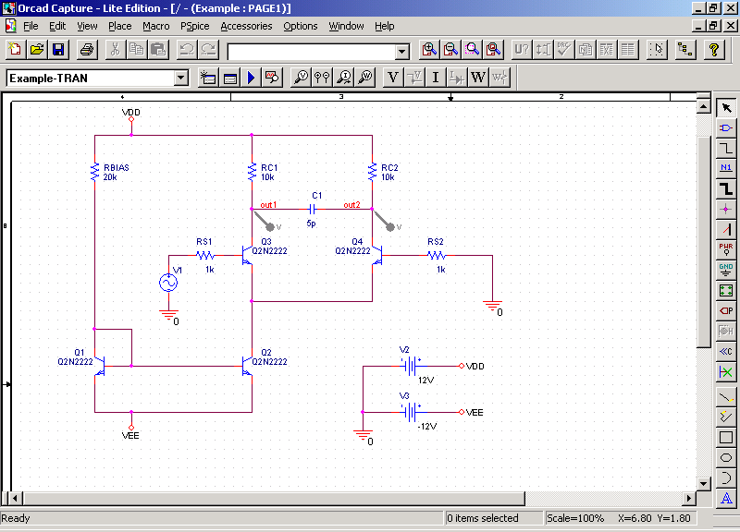

- Create a Net-List, save it to the disk:

* source EXAMPLE
RBIAS N00078 VDD 20k
RC1 OUT1 VDD 10k
RC2 OUT2 VDD 10k
RS2 0 N00112 1k
RS1 N00061 N00240 1k
Q1 N00078 N00078 VEE Q2N2222
Q2 N00315 N00078 VEE Q2N2222
Q3 OUT1 N00061 N00315 Q2N2222
Q4 OUT2 N00112 N00315 Q2N2222
V2 VDD 0 12V
V3 VEE 0 -12V
C1 OUT1 OUT2 5p
V1 N00240 0 AC 1
+SIN 0 0.1V 5MEG 0 0 0

For example, OrCAD software has a function “Create NetList”, which prepares a file of required format for PSPICE:
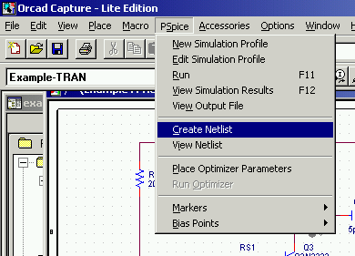

If the schema contains components which have additional libraries with PSPICE component models, insert links to this libraries into the PSPICE NetList:

*LIBRARIES:
* LOCAL LIBRARIES :
.LIB "C:\PROGRAM FILES\ORCADLITE\CAPTURE\LIBRARY\PSPICE\EVAL.LIB"
* FROM [PSPICE NETLIST] SECTION OF C:\WINDOWS\PSPICE.INI FILE:
.LIB "C:\PROGRAM FILES\ORCADLITE\CAPTURE\LIBRARY\PSPICE\EVAL.LIB"

Add line with real power supply parameters (minimal and maximal voltage – in this example 3 and 5 volts) and calculation step (in this example 1 volt).

.DC V1 3.0 5.0 1

Add line which will tell to PSPICE that it is an end of the file:

.END

Here is the entire file:
* source EXAMPLE
RBIAS N00078 VDD 20k
RC1 OUT1 VDD 10k
RC2 OUT2 VDD 10k
RS2 0 N00112 1k
RS1 N00061 N00240 1k
Q1 N00078 N00078 VEE Q2N2222
Q2 N00315 N00078 VEE Q2N2222
Q3 OUT1 N00061 N00315 Q2N2222
Q4 OUT2 N00112 N00315 Q2N2222
V2 VDD 0 12V
V3 VEE 0 -12V
C1 OUT1 OUT2 5p
V1 N00240 0 AC 1
+SIN 0 0.1V 5MEG 0 0 0

*LIBRARIES:
* LOCAL LIBRARIES :
.LIB "C:\PROGRAM FILES\ORCADLITE\CAPTURE\LIBRARY\PSPICE\EVAL.LIB"
* FROM [PSPICE NETLIST] SECTION OF C:\WINDOWS\PSPICE.INI FILE:
.LIB "C:\PROGRAM FILES\ORCADLITE\CAPTURE\LIBRARY\PSPICE\EVAL.LIB"

.DC V1 3.0 5.0 1
.END

- Build RAM Commander’s product tree with components used in the schema. Define calculation methods, resistors and capacitors styles etc. (all the necessary data except stresses, which will come from PSPICE).
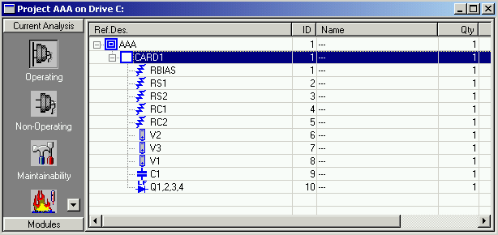

- Perform import from PSPICE:
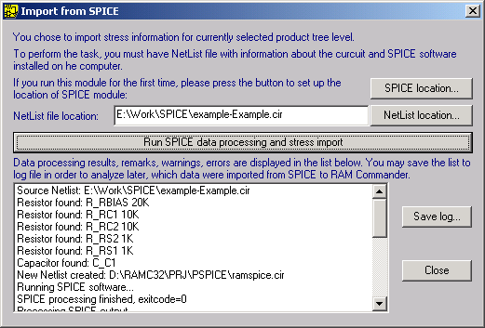

See the Log file – it shows stress calculated stress values:
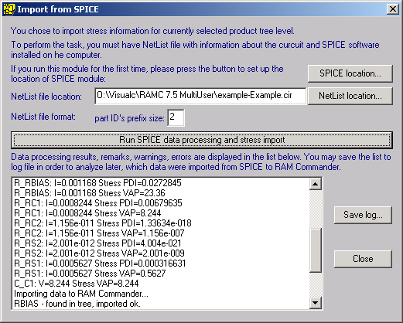

- See RAM Commander components data – the stress data was imported:
