Interface with SPICE - getting stress data from PSPICE for resistors, capacitors and diodes

RAM Commander now supports interface with SPICE software – you may run SPICE analysis and load analysis results as stress data to RAM Commander.
Note. To use this feature, you must have SPICE software installed (PSPICE, HSPICE, etc).
In RAM Commander: Create a project, set item parameters (calculation method, type and other parameters required by method).
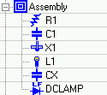

Have SPICE NetList file with circuit information prepared, for example:

* RESISTOR DIVIDER CIRCUIT
VIN 1 0 3.0VOLT
R1 1 2 1.0MOHM
R2 2 0 2.0GOHM
C1 2 0 2.0UF
RX 1 0 10GOHM
E2 3 0 1 0 0.1
CX 4 3 50UF
RL 4 3 500
DCLAMP 2 3 DMOD

.MODEL DMOD D
.DC VIN 3.0 5.0 1
.PRINT DC V(R1) V(R2)
.PRINT DC I(R1) I(R2)
.END

File must be of a valid format, component names must be the same as reference designator in your project, analysis type should be set to DC sweep (DC). Data will be taken for the highest voltage value in .DC statement.

To start analysis:
- Select assembly you wish to analyze in the Product Tree,
- From Modules menu, choose “SPICE…”.
- Press “NetList Location” button and choose NetList file for the currently selected assembly.
- Press Run SPICE.
SPICE software will run with your data, and resulting stress information will be imported into your project. You will see a complete logging of the process and results on the screen:
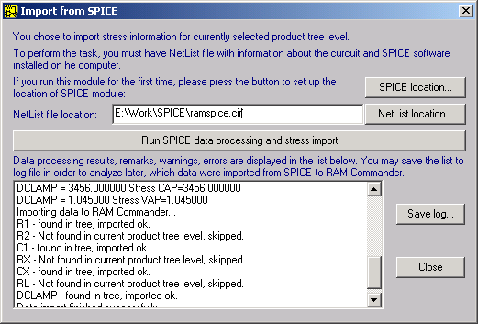

You may open item’s data screens and make sure that stress data were received:
