To import from Mentor Graphics software:

- Open project and choose Import Wizard from the Modules menu.
- Select Mentor Graphics from the Import file type list.
- Browse to select the file you want to import.
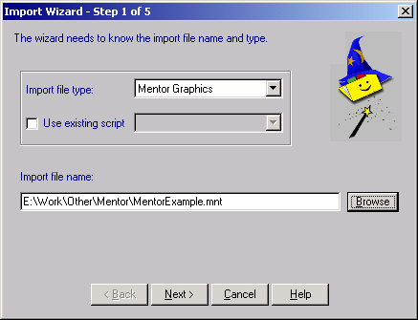

- Press Next and then Finish. The data is imported into the project:
