To import Field Data:
- Create a new project and open it.

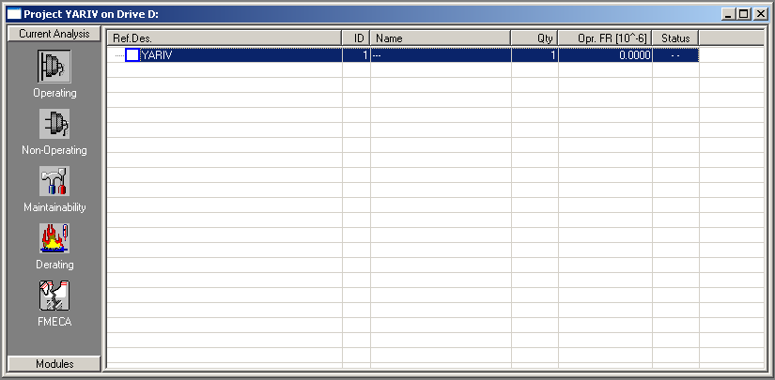

- From the Library menu, choose GPRD
GPRD is used in the RAM Commander as Reliability Field Data Database/Source.

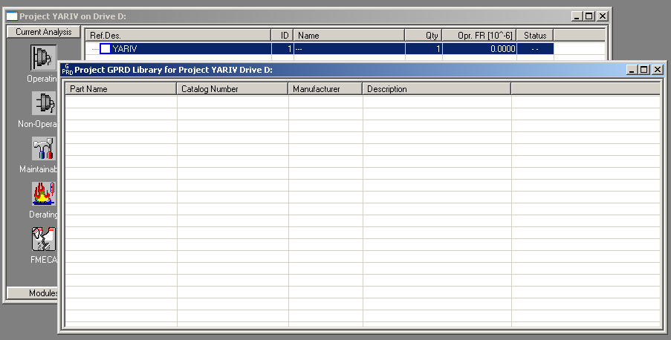

- From the Library menu, choose Import from ASCII. The FR Table Import dialog box is displayed.
- Enter a value for the width of fields (the following example is for importing FldData.dat file) and then select MTBF instead of FR from the drop-down list.

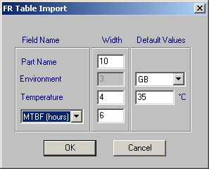

- Click OK.

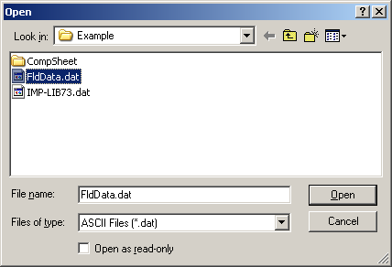

- Select the FldData.dat file and click Open. The date from the file is imported.
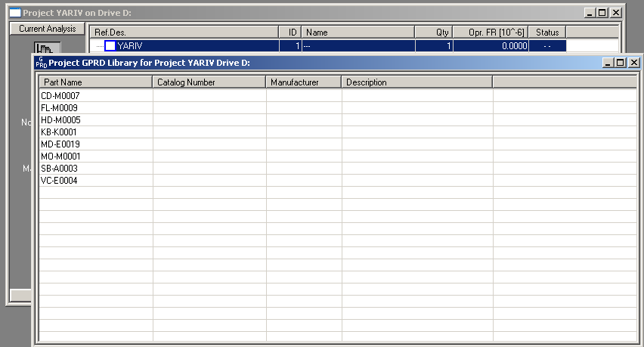

- Double click on one of the lines in the table, e.g. CD-M0007. The General Part Reliability Data dialog box is displayed.
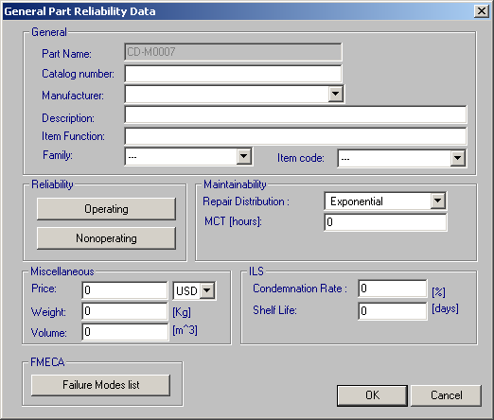

- Click Operating. The GPRD Operating dialog box is displayed.

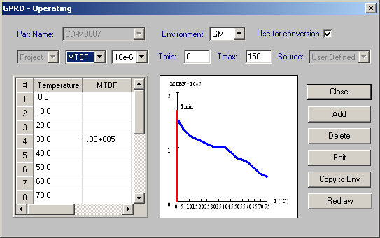

You can show how to use this data in the Product tree during reliability prediction.
To use field data during reliability prediction:
- In the product tree, choose Quick Create from the Tree menu.

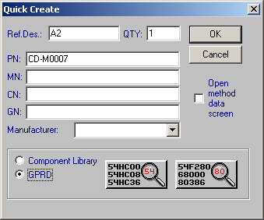

- Enter a value for Ref.des., CD-M007 for PN, and select GPRD.
- Click OK.
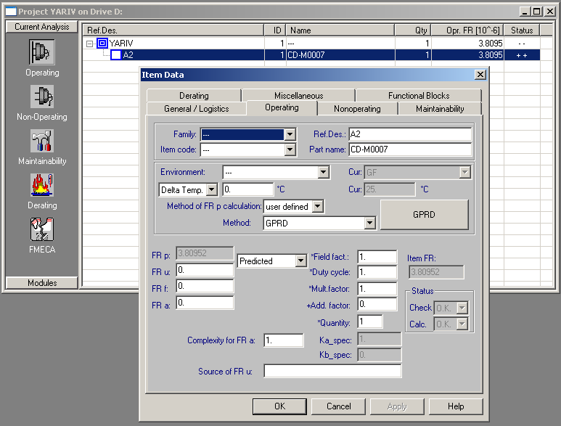

NOTE: In Load From Library module, you can prioritize the Field Data. For example, for parts (Part Numbers) where you have enough data from FRACAS, you can use field data in reliability prediction while for all other parts, you can use one of the other reliability prediction methods/standards (Telcordia, etc.).

