To import from Excel:

- Open project and choose Import Wizard from the Modules menu.
- Select MS Excel from the Import file type list.
- Browse to select the Excel file you want to import.
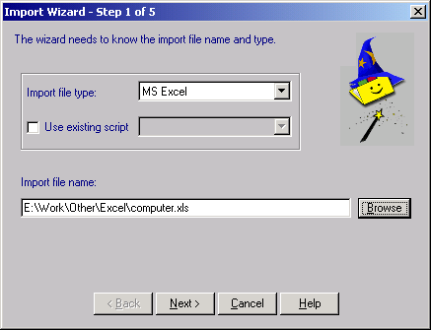

- Click Next.
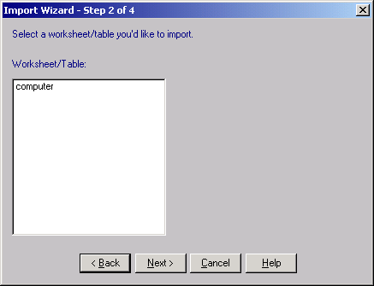

- Select the worksheet you want to import from the list and click Next.
- Map the columns in your Excel sheet to corresponding columns in RAM Commander database. To do it, click on each column in the table below and then choose the corresponding group and field name from the Group and Field Name drop-down lists above the table.
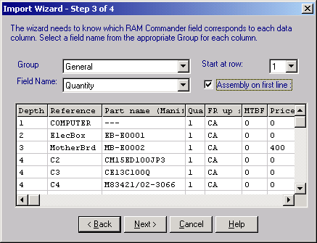

- Click Next and then Finish. Data is imported into your project.
