Troubleshooting – Import Wizard, Importing from Excel

Q: Not all the worksheets from my Excel file appear in RAM Commander Import Wizard – what should I do?
A: RAM Commander uses Microsoft ODBC drivers to access Excel file. It puts some limitations to Excel file:
- Worksheet name should start with Latin letter and should contain only letters and digits, without characters like .,()[]{}-+=#$%^&*`~ or spaces.
- Worksheet being imported should contain one consistent table (not multiple tables with spaces between them).
- Data type for each column will be defined using first 16 rows. If numeric data is entered to the cell type "Text" they it be interpreted as text, if text data is entered to cells with type "General" or "Numeric" they will be interpreted as numeric.

Q: What should I do when I have to import an Excel file, in which some fields that should be character type are defined as numeric (containing only digits) by Excel and therefore are imported into RAM Commander in numeric format?

A: If you enter data with digits only, Excel automatically defines the data as Numeric. If you wish to use the data as string data later, you should define the column as “Text” before data input.
However, there is a way to solve this problem. In the example below, the PartName column is defined as Numeric in Excel.
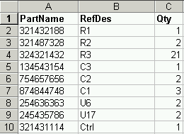
To convert the data to character format, do the following:
- Select an empty column (in this example, it is H2) and enter the single quote ' symbol.
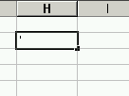
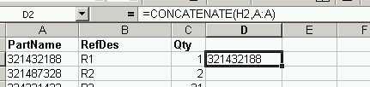
- Select another empty column and enter the formula =CONCATENATE(H2,A:A), where H2 is a cell where you entered the single quote ‘ symbol and A is column you wish to convert.

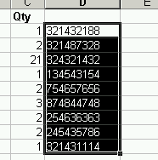
- Drag the point of the lower right corner of the field where the formula was entered to the end of the column to copy formula to all the data rows in this column.
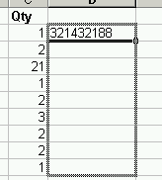

- Select the whole column with formula “CONCATINATE”, right-click on it and choose Copy from the pop-up menu.
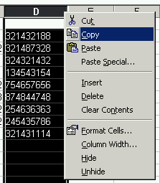
- Select an empty column, right-click on it and choose Paste Special from the pop-up menu. The Paste Special dialog box is displayed.
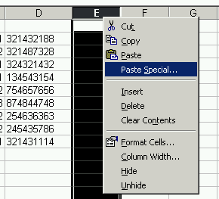
- Select Value and click OK.
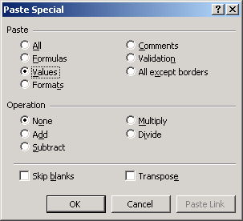
- Name the new column with "Text" at the end (in our example PartNameText). The file can now be imported into RAM Commander.

