How to update existing project data from external file (ASCII, Excel, Access) using Import Wizard

Imagine you have existing project. No project element’s data (like Part Name, Catalog Number etc.) was changed, and you have an Excel (Access, ASCII) file with new data. You may update product tree element’s data in the project from the external file automatically, if the Reference Designator is left unchanged.
The update should be done on specific assembly level only.

The procedure is described below:
- We have a sample project with one Assembly and 3 elements:
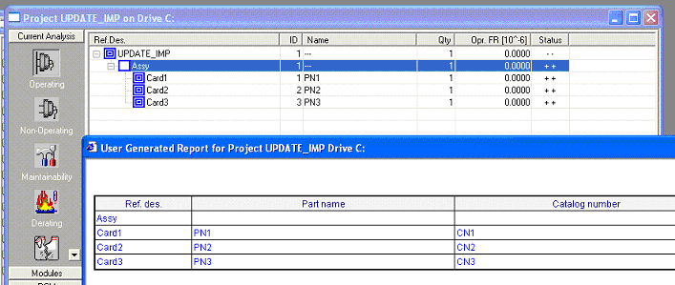

- We have also Excel file with assembly elements data (please note that the Reference Designator values in the Excel file and in Product Tree are exactly the same, but PN and CN values differs).
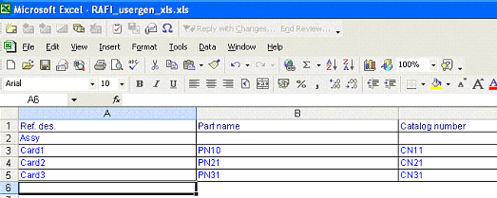

- Select the assembly Assy.

- Run Import Wizard, select specific file with assembly’s new data.
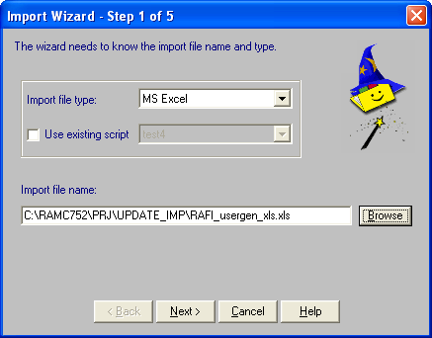

- Map Excel file fields to corresponding RAM Commander fields:
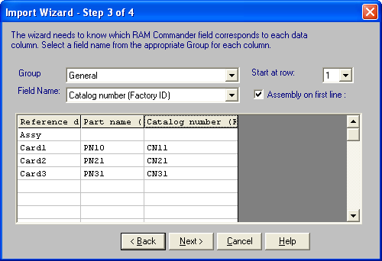

- Proceed with the Import Wizard.

- Check the project data after import – it is updated from the file (compare PN and CN fields):
