How to reorder product tree elements

- Reorganize
Each element in tree gets it’s number by order. If you delete some tree elements, the software does not renumber the elements automatically (for better performance) and you get a “holes” in component numbering:
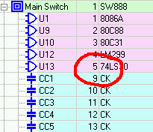
To renumber the elements use “Organize” option from the “Tree” menu:
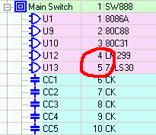

- Changing elements order
Let’s review a following example:
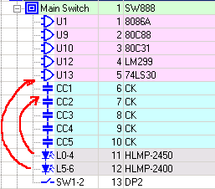
For example we wish to move two optoelectronic devices L0-4 and L5-6 to another location in the tree as shown by arrows. It could be done with the following procedure:
- Use “New Window” option to open one more Product Tree window:
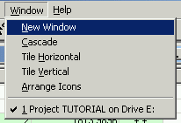
- Arrange two windows manually or using Cascade/Tile options so that they do not hide each other:
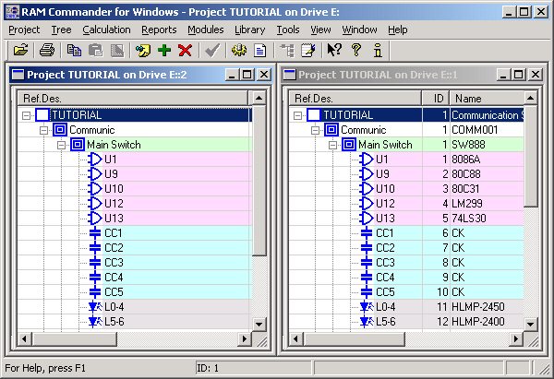
- Select elements you wish to move in one of the windows:
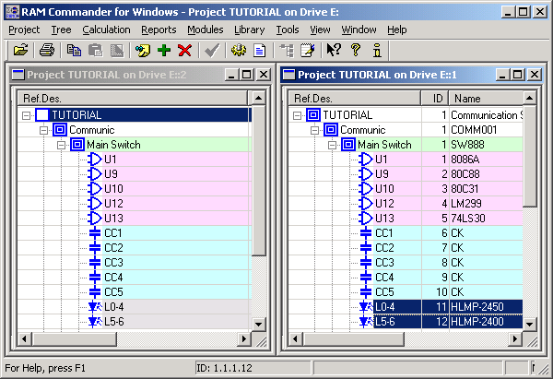
(for multiple selection, use Shift and Control keys together with mouse click).
- Holding Ctrl and Shift buttons together, drag the selected elements and move them to the second window, then drop them on the element which you wish to be located lower that these selected elements (CC1 element in this example).
- Elements should be moved to the new location:
