How to reduce part of RBD to Sub-RBD

- For example, you wish to move these 3 elements to sub-RBD.
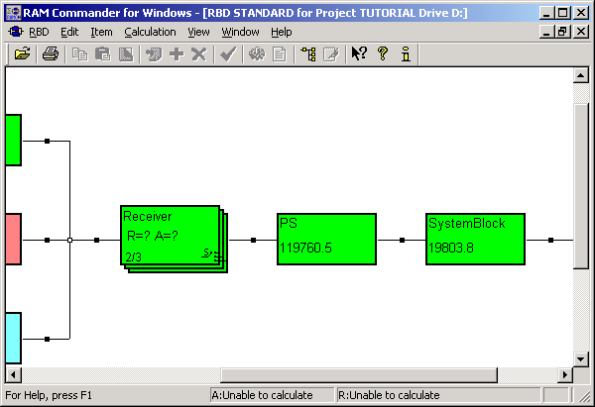

- Select the elements, drawing a rectangle (appears as dashed border):
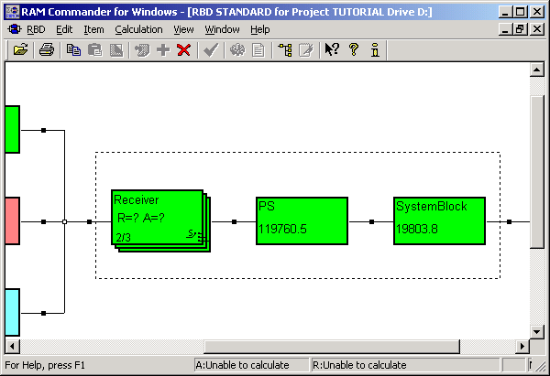

- Choose “Reduce & Save as Sub-RBD” from the Edit menu:
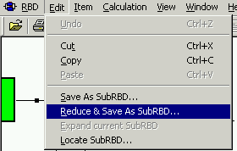

- Enter a new Sub-RBD name:
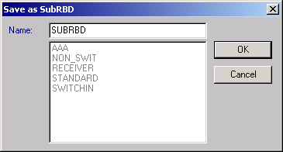

- The elements are moved to a new Sub-RBD:
