How to move parts of RBD

If you move separate RBD elements, connection point are not moved:
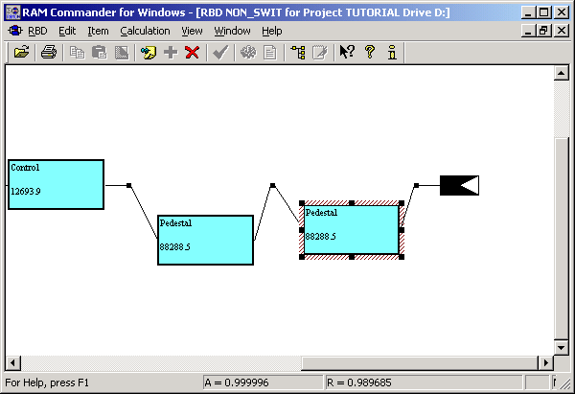

We recommend to select a block you wish to move, together with conection points, and then move.

- Select the block, drawing a rectangle around it (appears as dashed border):
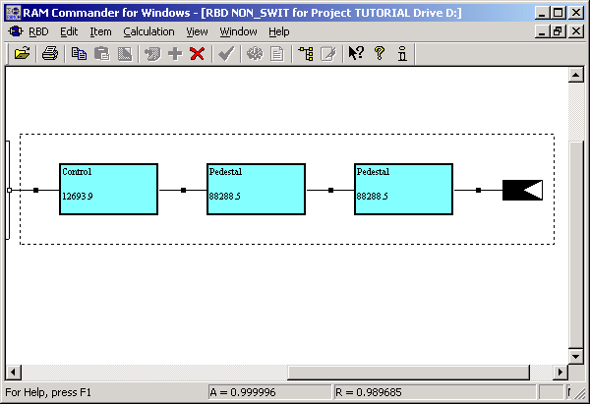

- Move the whole block, clicking on any free point inside it and dragging it to another location:
