How to set different reliability parameters for different parts in K-out-of-N section of RBD (split option)

K-out-of-N section is a parallel section with n items. A k-out-of-n section is functional when k or more of the n elements are operational. The section fails when n - k + 1 items fail at the same time.
Usually K/N section contains n identical elements – for example 3 identical power supplies, when 2 of them are required for normal system operation:
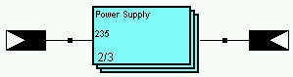

But sometimes elements in K/N section are not identical and have different reliability parameters. Split option solves this problem.
For example, we have K/N element where elements #1 and #2 are identical, but element #3 is different, and we need minimum of 2 elements for normal system operation.

- Create the K/N element with K=2 and N=3:
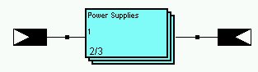
- Right-click on the K/N element and choose “Split” option from the popup menu:
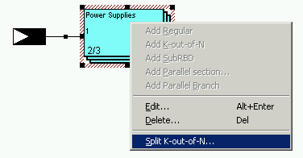
- Window with element ranges and their reliability parameters wil appear:
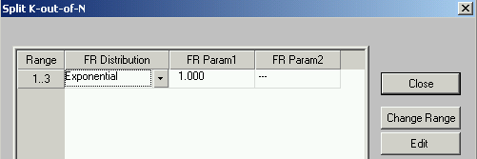

- To split the range, select line in the table and press “Change Range” button. Range definition screen will appear.

- Choose another range (in our example we split 3 elements into 2 groups – the first is [1,2] and the second is [3]) and press Ok button:
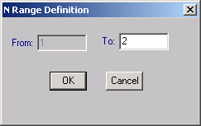

- The ranges table will be updated, now there are more lines with different element ranges:
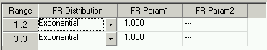

- Set different reliability parameters for different ranges. For example, elements 1 and 2 have MTBF=2000 hours and the element #3 has MTBF=1800 hours:
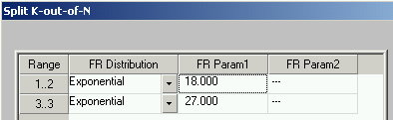

- Press Ok.

- The K/N with split element is created. You may enter the Split mode again to change ranges and reliability parameters.
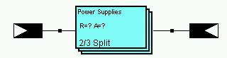

Note: RBD with K/N split may be calculated only using Monte-Carlo simulation.

