Pack to Box option usage example,
or
Using Pack to Box instead of embedding small subsystem from separate project into large system

We have a separate project with product tree and reliability analysis of a communication system:
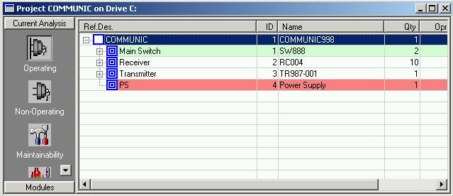

This system should be a subsystem of another system / systems which is/are located in another separate projects, for example the TUTORIAL project:
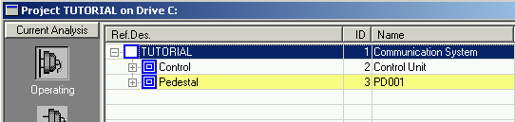

We may “pack” the Communication system to look like single part and then include it to other systems (for example TUTORIAL).

I. Pack to box
Pack to box (see user manual chapter "6_Libraries and Defaults.pdf" for more information) operation performed on Communication system will create a part in GPRD library with calculated Failure Rates for selected environments and a wide range of temperatures.

- Select system, select Pack to Box from the Library menu:
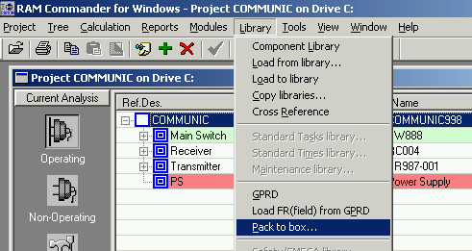

- Select list of environments which may be used (potentially) by other systems where the current system could be included:
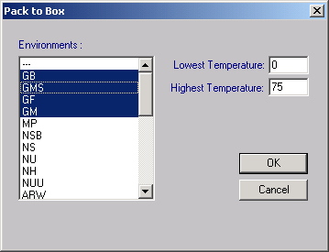
Press Ok.

- Open GPRD library, find item with system’s Part Name:
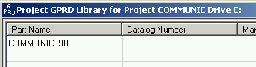

- Open it, choose “Operating” and review the generated FR tables for selected environments:
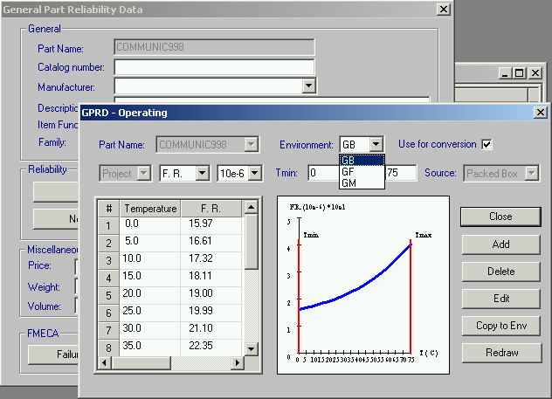

- To make this part data accessible for other projects, return to GPRD library main screen and choose “Copy to Global” option from the Library menu.

II. Insert the part into the large system project and connect it to GPRD data in global library.

- Open large system project, create new part (Communication), enter the same Part Name as used in a sub-system project, choose calculation method=GPRD:
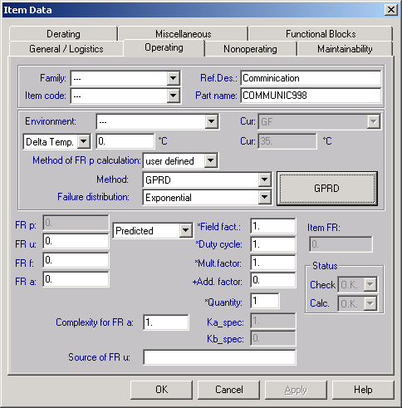

- Press Ok:
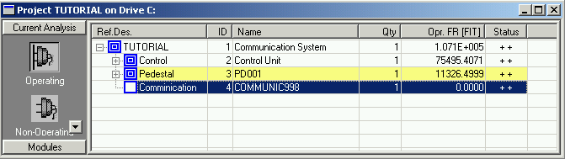

- Load the FR data from GPRD library, according to environment selected by the large system project: select “Load from Library”, set priority for GPRD:
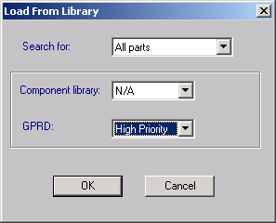

- The Communication part FR is calculated:
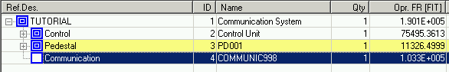
If part’s environment or temperature are changed, FR will be recalculated like all usual part’s FR are recalculated.

III. Sub-system analysis update
If the sub-system project is updated, the whole procedure should be repeated – Pack to Box, transfer to Global Library overwriting old data, and Load from Library in “large” system project.

