Loading a new Component Library to RAM Commander

To load a new Component Library:
- Insert the RAM Commander’s installation CD.
- Run RAM Commander and enter your login information.
- Close the Welcome screen.
- Choose Archive from the Library menu.
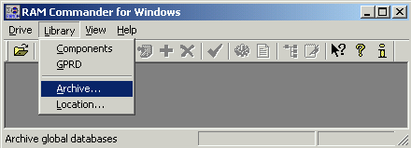
- Select the Restore with merge option in the Action panel and then select Component Library from the list, as shown below.
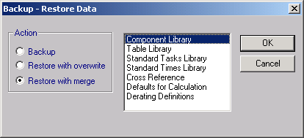
- Click OK.
- Browse to your CD-ROM to select the file name (,RAMC > LIBRARY > GLOBAL.RMW file).
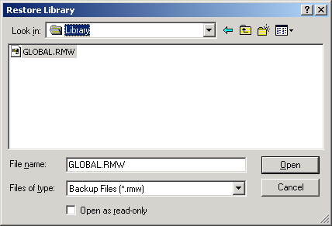
- Click Open. The library is loaded.
To view the contents of the library:
- Choose Component from the Library menu.

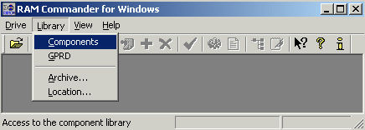

A library window is displayed.
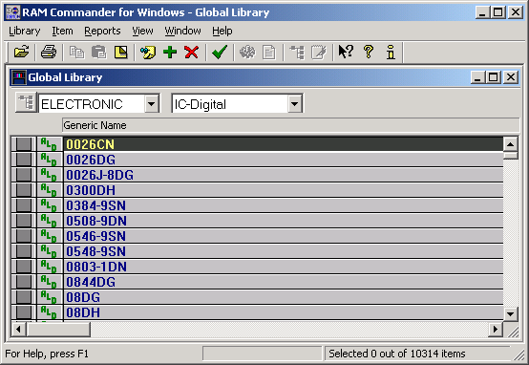
Only one item code is displayed on the screen.
To view another item code (such as Resistors, Capacitors etc.), choose the required item code in the second list box (where IC_Digital appears).

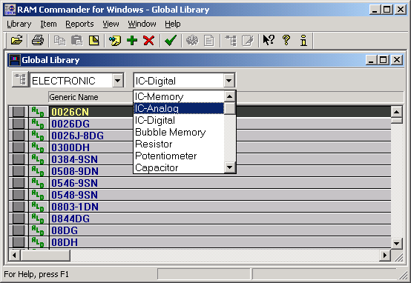

If the list is too long, it will be divided into several parts. You can switch between the parts using the View menu and choosing required part.

