How to: Installing two different versions of RAM Commander on one PC

RAM Commander does not actually support 2 different versions running on one PC. But if it is required, there is a way to perform such an installation.

If you have, for example, RAM Commander 7.51 installed in C:\RAMC32 folder and you wish to install RAM Commander 7.5 to another folder C:\RAMC75, use the following procedure to install a new version while preserving the old version.

- Create a folder, Ram Commander on the Desktop. Place the RAM Commander 7.51 shortcut icon in it (you may copy it from ALD Engineering group in the Startup->Programs folder) and change the shortcut’s name to display software version.
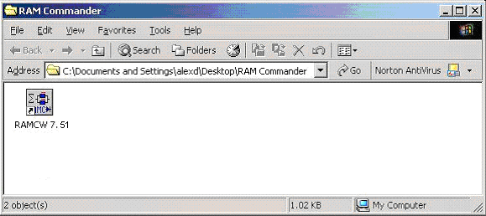

- Click Start button and choose the Run option.
- Enter regedit in Run dialog box and click OK.
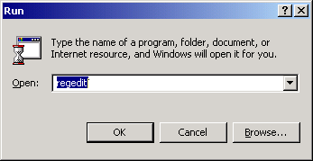

- Browse to locate the key HKEY_LOCAL_MACHINE\SOFTWARE\Advanced Logistics Developments and select the key.
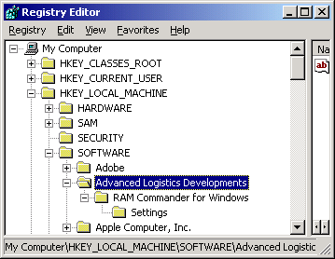

- Choose Export Registry file from Registry menu.
- Enter the file name (for example, ramcw 73) and choose the RAM Commander folder (which you created in step 1 on your Desktop) as the place where you want to save the file.
- Click Save.
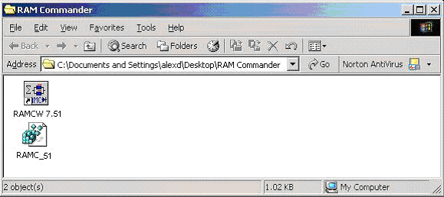

- Delete the registry key HKEY_LOCAL_MACHINE\SOFTWARE\Advanced Logistics Developments.
- Install the new version of RAM Commander to another folder (for example RAMC75). Do not use the same folder name for both versions!
- Place the RAM Commander 7.5 shortcut icon in it (you may copy it from ALD Engineering group in the Startup->Programs folder) and change the shortcut’s name to display software version.
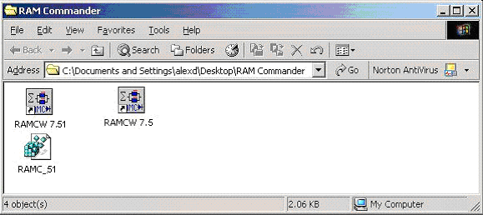

- Click Start button and choose Run.
- Enter regedit in Run dialog box and click OK.

- Browse to locate the key HKEY_LOCAL_MACHINE\SOFTWARE\Advanced Logistics Developments and select the key.

- Choose Export Registry file from Registry menu.
- Enter the file name (for example, ramcw 75) and choose the RAM Commander folder (which you created in step 1 on your Desktop) as the place where you want to save the file.
- Click Save. Now two RAM Commander versions are installed. You have RAM Commander folder with two icons for each RAM Commander version on the Desktop.
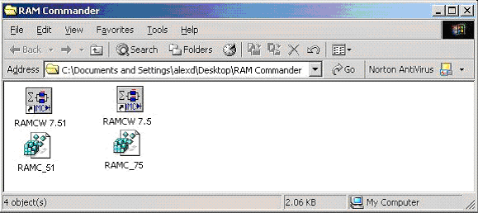

NOTES:
- Before any operation (run, uninstall, service pack installation, etc.), you should run the corresponding version’s configuration icon and confirm the changes (click Yes and then OK). Only after doing this can you run or update RAM Commander.
- Do not use the Start > Programs menu icons to run RAM Commander.
- To transfer a project from an older version to a newer version, use the Backup and Restore modes.

