HTML tables import to Excel: Date recognition problem solution

- Report generation

- Generate HTML report in RAM Commander.
- Right-click on the report, choose “Properties”, look at file name:
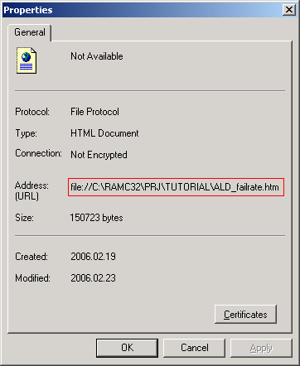

- Report import to Excel
- Run MS Excel, open new workbook/worksheet.
- Choose the following menu item:
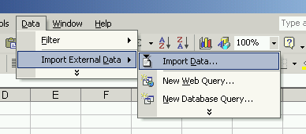
- Select report file name you wish to import
- You will get the following screen:
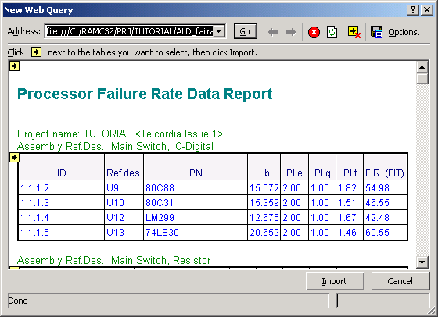
- Click all yellow arrow icons to select all tables you wish to import.
- Press “Options…” button, select options as shown below:
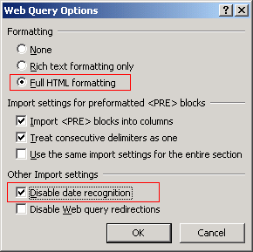
- Press Import. The tables will be imported without date recognition.

