How to export Fault Tree with sub-trees to MS Word

- For example, we have main fault tree with two sub-trees, as shown below:

- Open main fault tree, choose “FTA Diagram” menu option “Export to file”, click on “Export tree+subtrees to file”:
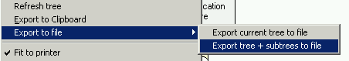

- Choose location for output files and the first file name (all other files will have the same name plus hierarchy code):
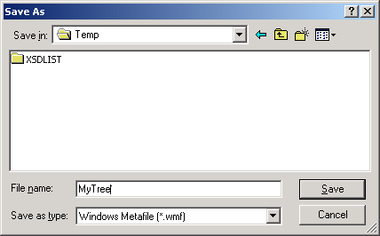
Then press “Save” button.

- RAM Commander will export tree to the specified file and all subtrees to files named as specified file plus hierarchy number like 1, 1-1, 1-2, 1-1-2 etc.
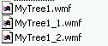

- Start MS Word, put cursor to the location where you wish to insert the tree image
- Select “Insert” menu, “Picture” option, “From file” option.
- Browse to the same location where FTA export files were stored.
- You will get a list of files. You may choose one of them to insert one specific file, or you may choose group or all of them using multiple selection options:
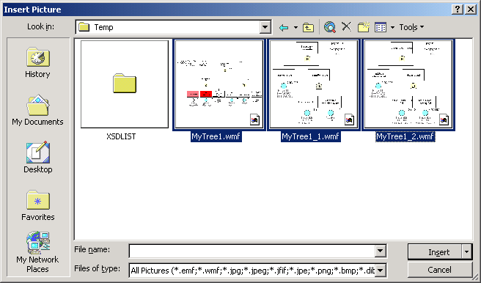

- Selected trees will be inserted into the document – see the result below.

