FMECA copy between projects

Import & Export of FMECA data

For example, we have 2 projects with identical tree structure. One (left) project has FMECA data, the second (right) has no:
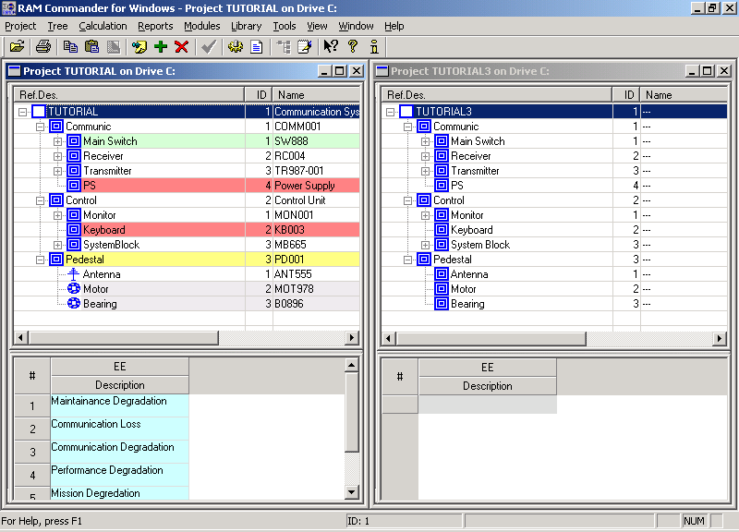

- In the FMECA project, select the tree top element and choose “FMECA Export” from Modules menu:
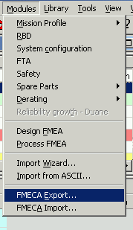
- Choose file name and save it to the disk.
- Switch to the project without FMECA, choose FMECA analysis mode, set up default phase and criticality if you need:
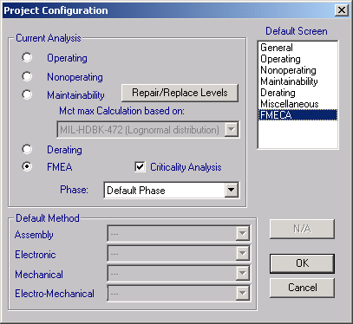

- Select the tree top element.
- Choose “FMECA Export” from Modules menu and point to the saved earlier excel file.
- Choose to import FMECA and TAM data:
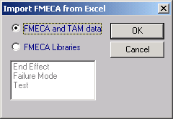
- FMECA data was imported, with all NHE-EE chains and libraries.
- If you need to import data from another phase, choose another phase in the source project, create and choose another phase in the destination project and repeat the procedure.

