FMECA copy from item to item

There is a possibility to copy FMECA data from one tree element to another.
For example, I have a following project:
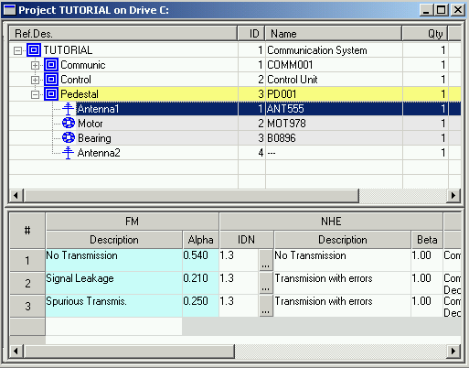

Antenna1 and Antenna 2 should have identical FMECA data. Antenna1 FMECA analysis is ready, and Antenna2 FMECA is empty. There are two ways to copy the FMECA data to Antenna2.

- Copy/Paste of element
We may just delete Antenna2, then Copy Antenna1 and Paste it to the same assembly, and then change it’s name to Antenna2:
  - Delete Antenna2
  - Select Antenna1
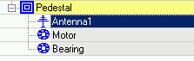
  - Right-click on the element and choose Copy from the popup menu.
  - Select parent assembly (Pedestal in my example).
  - Right-click on the element and choose Paste from the popup menu.
  - Answer Yes when you are asked about possibility to copy End Effects also:
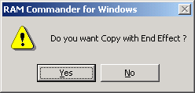
  - You will get 2 Antenna1 elements:
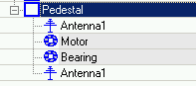
  - Enter one of them and change it’s data as required (for example ref.des. to Antenna 2 etc.):
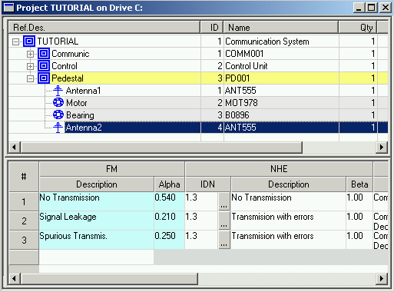

- Copy processor data between elements
There is a possibility to copy only FMECA from one product tree element to another:
  - In the project view, open another window with the same project (using “New Window” option from the Window menu)
  - Arrange windows (manually or using Tile option)
  - In one window select source element with FMECA data (Antenna1 in my example), in another window select target element without FMECA data (Antenna1 in my example), both windows in FMECA mode:
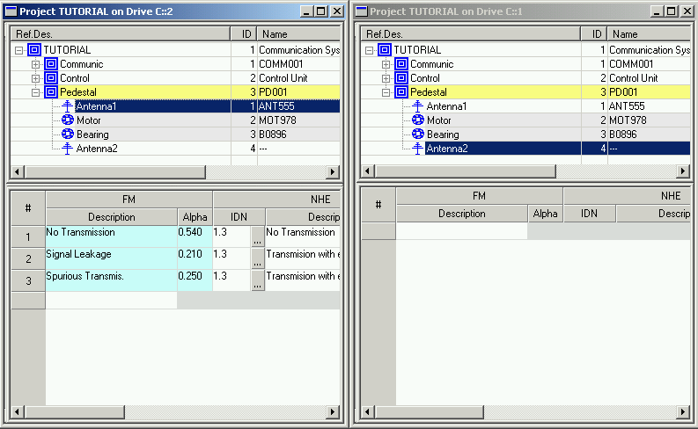
  - Make the window with source element active (left window in my example).
  - Choose “Copy processor data” from the “Tree” menu.
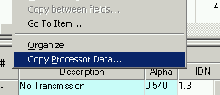
  - Choose target project and press Ok.
  - All the FMECA data is copied, with their End Effects, tests etc.:
