Export Excel table to fixed width ASCII file

1. Open your excel worksheet
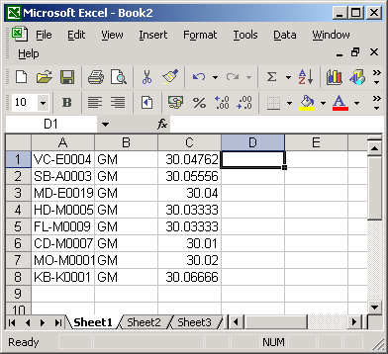

2. Choose empty column, enter the formula
=CONCATENATE(A:A, REPT(" ", 40-LEN(A:A)))
where 40 is a fixed length of the first column
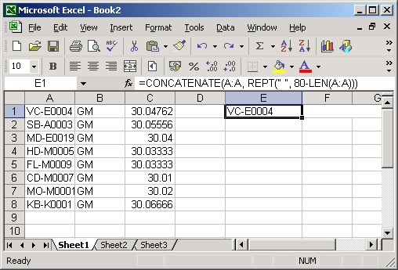

3. Spread the formula to the rest lines of this column
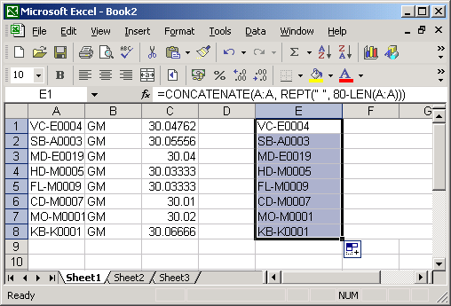

4. Choose the next empty column, enter the formula
=CONCATENATE(B:B, REPT(" ", 3-LEN(B:B)))
where 3 is a desired length for this column.
Then spread the formula to the whole column.
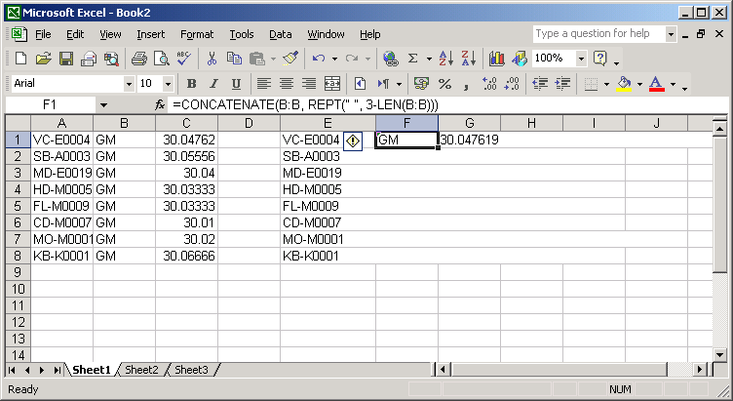

5. Repeat thre same procedure for each column you need to export.
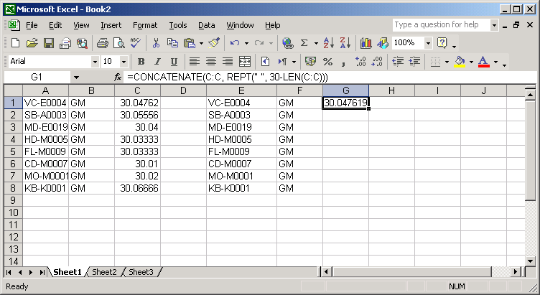

6. Select resulting area of new fixed width columns and copy it to the clipboard (Ctrl+C).
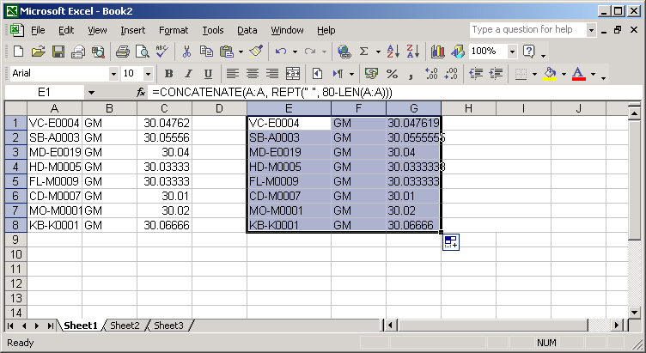

7. Open notepoad.
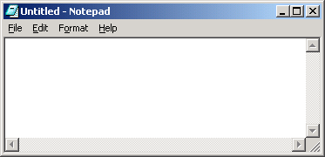

8. Paste the clipboard.
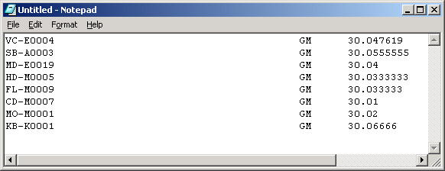
We got the ASCII file of fixed width format. Save the file.

