To copy a project (or save it under a new name):

- Open the List of Projects.
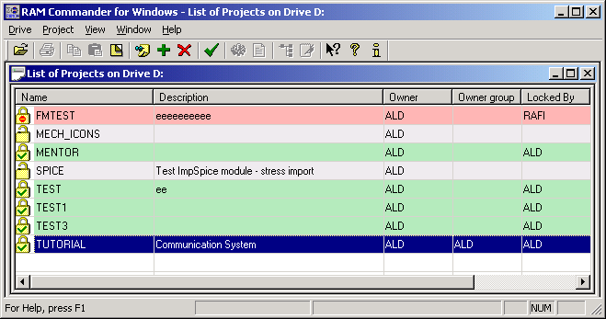

- Choose New window from the Window menu. Another List of Projects opens.
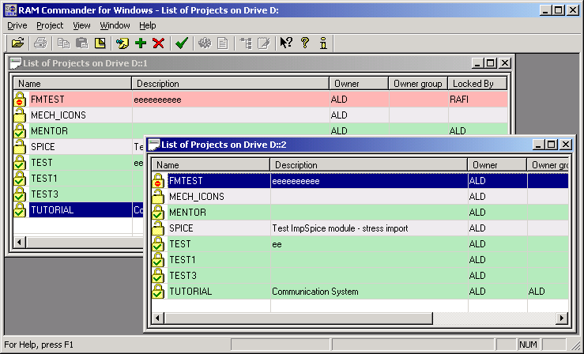

- Using the mouse, select a project from the list (for example, TUTORIAL), drag it to the new window and release the mouse button. The following message appears.
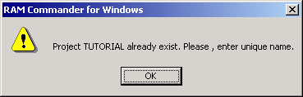

- Click OK. The New Project Name dialog box appears.
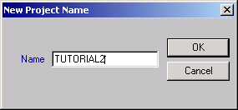

- Enter a new name for the Project.
- Press OK. The Project is copied to the Project List under a new name (e.g.Tutorial2).
