RAM Commander – using Calculation defaults

RAM Commander maintains calculation defaults with default calculation parameters for each method for each item code and each component type/style in each item code:

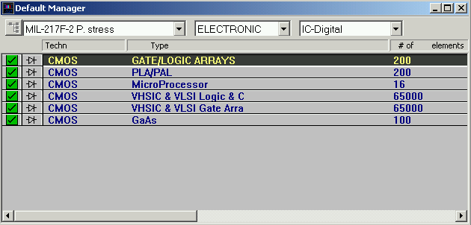

To enter Defaults manager, enter a project and choose “Defaults manager” from the “Project” menu.

There are different defaults databases – global (for each RAM Commander software installation) and local (inside each project).

Below are some maintenance procedures for calculation defaults libraries.

Procedure 1. Restore global calculation defaults from backup.
- Open RAM Commander, close all child windows.
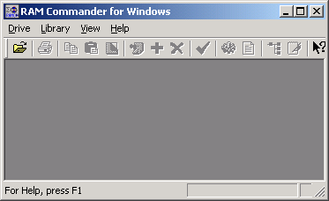
- Choose “Archive” from the Library menu:
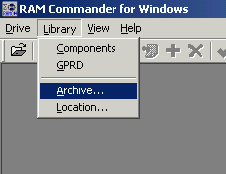
- Choose the following options and press Ok:
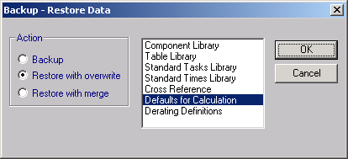
- Then choose the file with the backup.
- The defaults will be restored.

Procedure 2. Backup global calculation defaults.
- Open RAM Commander, close all child windows.
- Choose “Archive” from the Library menu:
- Choose the following options and press Ok:
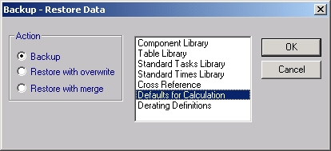
- Then choose where to save the backup file and press Save button.
- The defaults will be stored.

Procedure 3. Copy calculation defaults from global defaults database to specific project
- Open the project
- Choose “Transfer” from the “Project” menu.
- Choose the following options and press Ok:
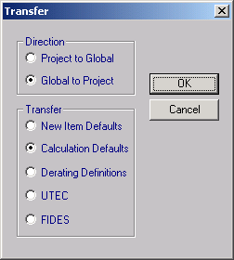

Procedure 4. Copy calculation defaults from the specific project to global defaults database
- Open the project
- Choose “Transfer” from the “Project” menu.
- Choose the following options and press Ok:
