A.L.D. Software:

RAM Commander 7.7
D-LCC
FavoWeb

Modules Description

© 2010 A.L.D. Ltd. All rights reserved.
No part of this material may be reproduced, in any form or by any means,
without the prior written permission from the A.L.D. Ltd.

TABLE
OF CONTENTS

Basic Module 4
Functions and Features of the Basic Module 5
GPRD Generalized Part Reliability Data 9
RBD Reliability Block Diagrams with Monte Carlo Simulation 11
‏SPR Spares Quantity Estimator 15
‏SpOpt Spares Optimization 16
Optimization algorithm 18
Markov Chains Module 19
DRT Derating Guidelines & Reports 21
RPGN Tree Data Report Generator 22
Reliability Prediction Models 23
‏MNT Maintainability Prediction 27
MSG-3 30
RCM 32
Component libraries 35
FMECA Testability Analysis 37
Process & Design FMEA 39
Fault Tree Analysis (FTA) 41
Safety 44
Master Minimum Equipment List (MMEL) 47
Event Tree Analysis Module 49
D-LCC - Software for Decision by Life Cycle Costing 52
FavoWeb – Web-based Dynamic FRACAS 54

RAM Commander

Basic Module
The basic RAM Commander module provide s everything necessary for primary reliability prediction based on one of the prediction models for electronic equipment (MIL-HDBK-217, Telcordia, British Telecom, UTEC 80-810, ItalTel, etc.), and mechanical and electro-mechanical equipment ( NPRD-95, NSWC-98 for mechanical equipment, etc.). In addition, you can perform additional tasks and options related to reliability analysis and evaluation:
Reliability Allocation
Pareto Analysis
Temperature curve (the failure rate or MTBF as a function of temperature)
Mission Profile
Global Change utility
Store all ILS/LSA data

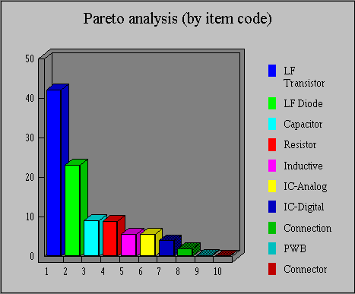

Functions and Features of the Basic Module
- ‏Reliability Allocation with user-defined complexity factors
- ‏Reliability prediction (‏Part Stress Analysis) using reliability prediction models
- Temperature curves — the failure rate or MTBF as a function of temperature:
- Regular
- Multi-Environment for several Environment classes
- Multi-Items for several project items on one graph

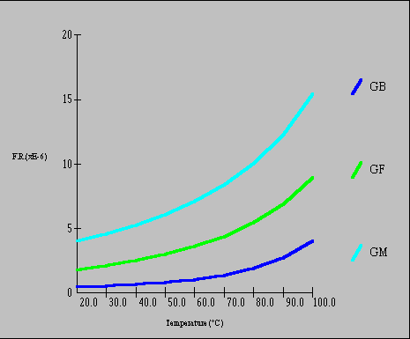

‏Pareto analysis identifies components or component families that contribute most significantly to system or assembly failure rate — about 80% of total failure rate
- Pareto Analysis by component's names
- Pareto Analysis by component family (Resistors, Capacitors, Digital IC etc.)
Mission Profile Analyzer calculates reliability according to Mission Profile defined as a sequence of Mission phases. For each Mission phase, the following data is required:
- Operating / Non-operating
- Mission phase description
- Mission duration
- Environment and temperature
- Test performance/test efficiency (α)
- Number of on/off cycles per 1000 hours (for non-operating phases only)

Mission Profile report
for project: RADAR

Report name : MISSION PROFILE
Report description: List of Mission Phases
‏Mission Phase | OP/NOP | t (hours) | Env | T (°C) | Nc | F.R.(*E-6) | α | MTBF | F.R. *2 | R (t)
Storage  Transportation  Flight | NOP  NOP  OP | 48.0000  2.0000  0.4000 | GB  GM  AUF | 25.0  35.0  55.0 | 2.0  0.0  0.0 | 0.041700  0.526131  14.435273 | 0.9  0.0  ---- | 2.40E+007  1900666.6  69274.8 | 2.0016  1.0523  5.7741 | 0.999998  0.999999  0.999994
 |  |  |  |  |  |  |  |  | Σ(1-α)*FR*t | R=πR(t)
 |  |  |  |  |  |  |  | Entire Mission | 7.0265 | 0.999993

- Built-in reports
- A wide variety of reports
- User controlled report format
- An ability to generate reports for the entire system, or for a part of the product tree
- Flexible, convenient and time saving data input:
Fast and easy data entry (“Massive Entry”) for the same component type (e.g., IC-Memory, LF Diodes, Resistors, etc.)
Manual entry of failure rates (field data or other sources) for a part of the system elements (See also TBL module)
Extensive set of defaults
‏
- Easy move and copy
Copy part data between segments of the same tree, or between different trees ("Drag and Drop")
- ‏Global Change Utility (GCU)
This function enables global changes of many RAM parameters, i.e. quality level, stress factor, etc., for the entire system or for any part of the product tree.
A global change can be applied to a whole set of the component family (e.g., IC's, resistors) or to a subset of the component family (e.g., EPROM IC-Memories or RCR resistors) or a special group of components (i.e., transistors with a certain power stress ratio). GCU gives you the possibility of a thorough sensitivity analysis/"what if" and optimization.
- ‏Import Wizard
Easy to use Import Wizard allows importing of product tree files ( Bill of material) of all commonly used formats: MS Excel, MS Access, HTML, Text, etc.
- ‏Simultaneous Work
RAM Commander allows simultaneous work of a number of users on the same project. Some of the users may perform Reliability analysis, while other users input FMECA, or draw RBD diagrams or work with Fault Trees – all inside the same project.
- ‏Local Area Network (LAN) support
- ‏ Work through Terminal Server or Citrix
RAM Commander supports installation configuration, when clients are connecting to RAM Commander through Terminal Server or Citrix software.
- Automated ‏Data Interface with Cross-Reference
The Automated Cross-Reference searches components in RAM Commander Component libraries by Catalog number, Military number, Part name, and thus eliminating the need to manually enter data for any component listed in the library.
- Library Import
RAM Commander provides a utility for importing component data from external libraries or databases. RAM Commander reads the library import file and encodes it into its own library. This saves the laborious task of manually keying an entire component library. If you have a reliability project on another system, use the import utility to convert it into the RAM Commander format.
- Connection with FavoWeb (see chapter FavoWeb) : send and receive field MTBF data and FMECA End Effects library through Web.
This option allows connection between the two products of ALD Group – RAM Commander and FavoWeb (FRACAS). The possibilities are:
- import field MTBFs from FavoWeb to RAM Commander
- Export End Effects from FMECA analysis from RAM Commander to FavoWeb
Connection’s technology is Web Services located on FavoWeb’s web server.

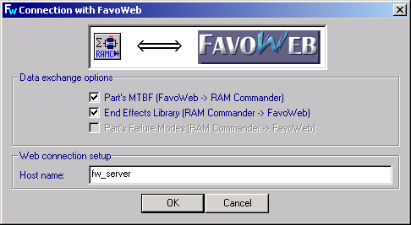

GPRD
Generalized Part Reliability Data
GPRD Module covers:
- General Part Data (Part and Catalog numbers, manufacturer, price, condemnation rate, Maintainability repair distribution)
- Reliability data (field failure rates tables)
- FMECA data (Failure Modes list for the part)
The module gives possibility to store various data for a part and retrieve this data for easy creation of the new product tree items with the same Part Number.

Two separate GPRD libraries are supported – Global and Local. Global Library is common for all projects; in addition each project has its own Local Library.
The GPRD module allows the use of available field and manufacturer’s data in the process of reliability analysis, and provides prediction of the Failure Rate for unknown temperature values.
Sometimes modules of the system under analysis are off-the-shelf products with existing field reliability data. In such cases, it would be necessary to manually enter or automatically import (such as from FRACAS) the available field data for the reliability analysis.

The GPRD module gives an efficient solution to this problem and extremely useful when:

Field/Manufacturer’s Failure Rates are known only for a few temperature values
A complex assembly is repeated in the project
The display of project components is not desirable for security or other reasons

Building Failure Rate Tables
Failure Rate (FR) Tables Library is keyed by part name.
The data in the FR table is stored with reference to environment and temperature.
The source of the data in the FR table may be field/manufacturer reliability data or calculations performed earlier.

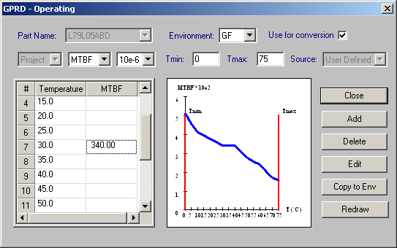

Using Failure Rate Tables
The search for a part failure rate is done automatically, by Part Name. If the data for the required temperature or environment does not appear in the FR table, the program will automatically perform interpolation or extrapolation, as necessary. The interpolation/extrapolation is based on the Reliability Toolkit by RAC, USA.
The subsequent Temperature Curve or Mission Profile analysis will be sufficiently accurate.

Pack-to-Box
The Pack to Box option is used to “pack” failure rates for a given environment and several ambient temperatures into a failure rate table. This table can then be transferred to other RAM Commander users in their projects.

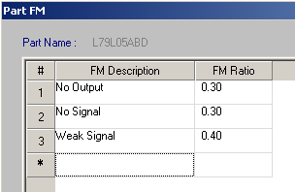

RBD
Reliability Block Diagrams with Monte Carlo Simulation

The RBD module is for functional Reliability and Availability analysis of systems with various reliability distributions, and includes all types of redundancy and repair factors. The Basic module provides the basic reliability calculations and predictions for non-redundant systems (all connections are series). The RBD module uses all necessary data defined in the Basic module. All types of reliability configurations are supported by RBD module:
- Series
- Parallel
- K out of N: * active redundancy (hot), stand-by (cold), partially loaded (warm);
- with repair, without repair, with restricted repair.
All common distributions of time to failure and time to repair are available:
- Exponential
- Normal
- Log-Normal
- Weibull
- Erlang
- Uniform and others
Features
- Interactive graphic editor with “Drag and Drop” feature providing intuitive display and convenient manipulation tools for creating of any RBD configuration
- Simple and fast transfer of reliability and maintainability item data to the RBD module by selecting the target and source items on the graphic RBD screen.
- Flexible zoom, color palette, direct printing of any RBD configuration
- Database for each element includes:
- identification parameters: ref. des., part number, description, etc.
- type of time-to-failure distribution and corresponding parameters (e.g., MTBF, Sigma, etc.)
- type of time-to-repair distribution and corresponding parameters

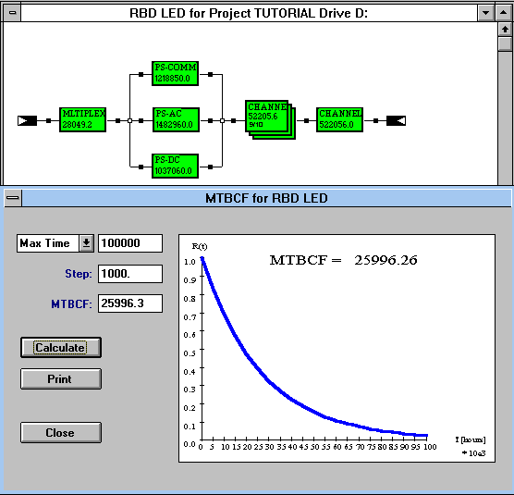
Advanced calculations
The RBD module has two calculation approaches: analytical and simulation (see MCS module description below). The analytical technique can be used for exponential distributions and in some other relatively simple cases. For each RBD, a graph of the reliability function R(t) can be drawn and MTBCF (Mean Time Between Critical Failures) can be calculated using numeric integration. High speed algorithms perform very accurate calculations with large number of steps.
$\text{MTBCF} = \int_{0}^{∞}{R(t)\text{dt}}$
Reliability of Various Configurations
System Configuration is a new feature (starting from RAM Commander 7.1) answering the requests of our customers who needed to evaluate reliability of the various configurations of systems built from the same blocks. Utilizing the already created product tree, user can easily create an unlimited number of configurations where system blocks appear in different quantities and in various combinations of reliability models.
- Creation of unlimited number of graphically presented system configurations by simple drag & drop from the product tree
- Automatic conversion of system configurations into RBD
- MTBCF calculation per system configurations
- Synchronization of system configurations and product tree
- Reports of calculated values per a system configurations and comparative report for selected configurations
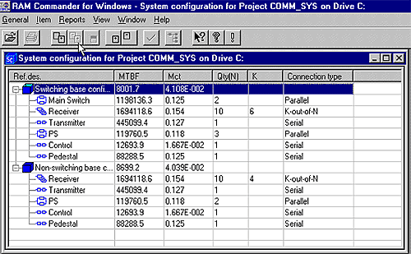
RBD with Monte Carlo Simulation

Monte Carlo simulation module allows evaluation of Reliability and Availability for arbitrary configurations when there is no analytical solution. This includes the following cases:
Non-exponential distribution of time-to-failure (Normal, Weibull, etc.)
Complex reliability configurations, including standby, partially loaded (warm) and active redundancy
Full or restricted repair with non-exponential distribution of time-to-repair
Analysis under Non-steady, transient state
Dependent RBD elements
Analysis of periodical inspection policy
Splited K-out-of-N
K-out-of-N with non ideal switch

This module allows you to deal with rare events and systems consisting of ultra-reliable and ordinary elements. When “nothing happens” the simulation clock is advanced to the next event, unlike to the “clock driven” simulators where a sampling needs to be performed at each Δt.
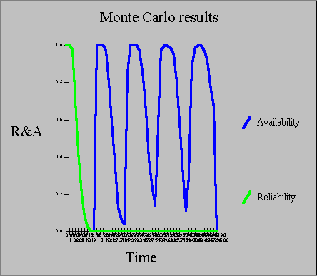

‏SPR
Spares Quantity Estimator
The SPR module provides fast calculations of necessary spare parts stocks.
The criterion used in the calculation is NSP — No Shortage Probability.
The SPR module treats both repairable and discardable parts at all Maintenance levels: Organizational, Intermediate, Depot and etc.
The list of parts and reliability data is taken from RAM Commander data files and needs no separate entry. The SPR module is fast and simple to use. It requires minimum of data entry, since it uses data and calculations already stored in RAM Commander files.
Additional data required for running the SPR module:
- prediction period (in years)
- number of systems is operation
- operation hours per day per system
- repair turnaround time at Intermediate and Depot levels (days)
- required NSP

‏SpOpt
Spares Optimization

Spare Parts analysis and optimization:
Optimization can be performed on two criteria: Total No Shortage Probability and Availability.
Cost⎯Availability optimization of repairable and discardable parts for all levels of repair: Organizational, Intermediate, Depot and etc.
Spare parts optimization for a variety of mission applications, including:
when the primary restriction is weight or volume, such as for fly-away kits
when no repair or supply of spare parts is permitted (unsupported mission).
Part and reliability data are taken from the RAM project, thus minimizing data entry.

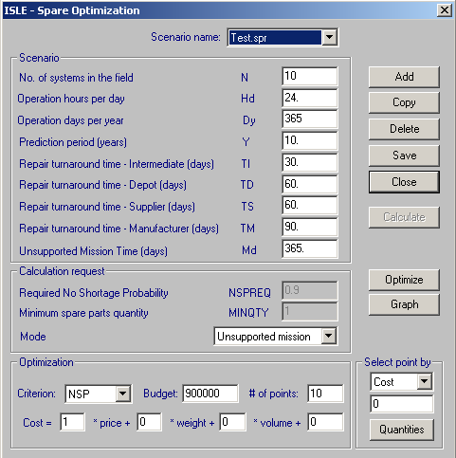

Additional data required for running the SPOpt module:
Unsupported mission time (days).
Optimization criteria: NSP or Availability.
Maximal budget for spare parts
Cost of each part.

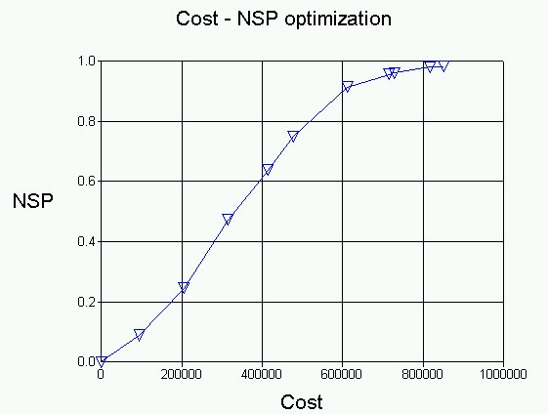

Optimization algorithm
The optimization algorithm is based on convex programming as outlined in the flow chart below.

Markov Chains Module

The Markov chain technique and its mathematical model have been demonstrated over years to be a powerful tool to analyze the evolution, performance and reliability of physical systems.

RAM Commander Markov is a powerful tool with the following features:
- Up-to-date, intuitive and powerful Markov Chain diagram interface with possibilities of full control over the diagram: elements location, colors, styles, zooms etc.
- Convenient ways of diagram printing and simple Copy & Paste transfer to other applications
- Calculation of Steady-State Mode
- Calculation of Time-Dependency Mode
- Calculation of Availability, Unavailability, Failure and Repair rate and frequency, MTBF, MTTF, MTTR, Reliability/Unreliability and other system parameters.
- Results output:
  - System parameters for selected times as table or graph
  - State probabilities for selected times as table or graph
  - Steady-State results report
  - Transition Matrix report
  - States and Transitions data report
- Results export to Excel, Word, HTML formats.
- RGP
Reliability Growth Planning

Reliability Growth modeling concept
The Duane model (described in MIL-STD-1635) is the most widely used method for reliability growth planning, testing and tracking. In this model, as long as the effort to improve the reliability of electronic equipment continues, the tested system MTBF is proportional to T^{α}, where T is the cumulative operating time and α is the rate of growth. The cumulative mean time between failures MTBF_{c} is measured during testing and then divided by (1-α) to convert it to the current instantaneous MTBF_{i}, i.e., the instantaneous MTBF (MTBF_{I}) is calculated as follows:
$${\text{MTBF}}_{I}=\frac{{\text{MTBF}}_{c}}{1−α}$$
MTBF_{c} is plotted versus cumulative test time on Log-Log paper, where the growth regression is a straight line with slope coefficient α. The test time at which the growth line reaches the required MTBF (MTBF_{R}) is the expected duration of the Reliability growth test.

Features and Results
The default values of MTBFI and Initial test time for Reliability Growth Planning are defined in accordance with MIL-STD-1635.
The default MTBF/R values for each project item are those predicted by the RAM Commander.
Reliability Growth calculation can be performed for the whole system, for any subsystem, or even for an external item that doesn't belong to the current project.
Reliability Growth Test plan and expected remaining time to test accomplishment are presented.
Calculation of a Confidence Interval for a selected Confidence Level using the new Bootstrap technology. (A new statistical technology named “Bootstrap” reproduces the origin sample as many times as necessary, and all new samples have absolutely identical statistical properties).
Reports for all failures available or only for the last N reported failures.
Tabular or graphic report presentation.

DRT
Derating Guidelines & Reports

The Derating module is used to analyze the overstress of components under current temperature conditions.

Stress Derating Policy
The module provides a tool to define Derating Guidelines and identify overstressed components, i.e., those working under stress exceeding the specified rating value.
Rating, or maximum rated stress, is the specified value of temperature, power, voltage or current that define the absolute maximum stress limits. Exceeding these values creates a high probability of part damage/failure. The maximum rating is specified in the part specifications or in standard for this type of part. It is a well known practice in many companies to define limit values of stress for various components as a function of temperature. These limits, "Derating Guidelines", are part of the company policy of component usage.

Features and Results
The user can define more than one set of Derating Guidelines, for general use and for particular applications. For each type (or style) of electronic component (e.g., RLR, RCR styles of resistor) its own Derating Guidelines can be defined.
A report created by the Derating module includes all components in the selected part of the system, or only overstressed ones. The overstressed components are appropriately marked in the report.
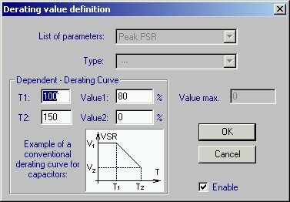

The user can run Spice software for automatic stress calculation and then import spice results for derating evaluation.

RPGN
Tree Data Report Generator

The Report Generator is a powerful and flexible facility which allows to create an arbitrary user defined report. It is intended for creating the tree data reports.
A report definition should be created for each desired report by means of the easy-to-use Report Generator input screen. Each report definition consists of the two groups of parameters. The first group is comprised of the parameters which define each report column. The second group includes a set of parameters defining the appearance of a report. Each report column (field) is defined by the user. The information required to define each column of the report includes the following parameters:
- identifier of a data field (pertaining to a specific RAM Commander tree data group);
- number of characters or digits (including a number of digits after the decimal point);
- a title of a column to be printed in the header of this report column, etc.

Parameters pertaining to the whole report are as follows:
- report title which is printed in the center of the first report page;
- character(s) for separating columns in the report (by default " | "), etc.
- product tree display order
- items to include in the report

A generated report is displayed on screen and is stored in a file. This report like any other RAM Commander predefined report can be viewed, edited, printed and so forth.

Reliability Prediction Models
‏MIL-HDBK-217 Part Stress & Part Count
MIL-HDBK-217 Module for Parts Stress reliability prediction based on
MIL-HDBK-217 E, F, F Notice 1, F Notice 2.
MIL-HDBK-217 Parts Count reliability prediction Module based on
MIL-HDBK-217 E, F Notice 1, F Notice 2 methods for Parts Count.
217Plus - Based on Handbook of 217PlusTM Reliability Prediction Models, 26 May 2006
‏BEL
BellCore Module for reliability prediction based on Bellcore document TR-NWT-000332, (Issue 4, Issue 5, Issue 6).
Telcordia
Telcordia SR332, Issue 1, May 2001;
Telcordia Issue 2, Reliability Prediction Procedure for Electronic Equipment, SR-332, Issue 2, September 2006
CNET RDF 93 Revision 2/95 Module for reliability prediction based on
CNET, French reliability prediction method for commercial applications.
UTE C 80810, RDF 2000, IEC 62380
RDF 2000 (UTEC 80810) is the new version of the French reliability prediction standard that covers most of the same components as MIL-HDBK-217. In RDF 2000 the difficult to evaluate environment factor is replaced by equipment mission profiles and thermal cycling. RDF2000 provides complex models that can handle permanent working, on/off cycling and dormant applications. As this standard becomes more widely used it could become the international successor to the US MIL-HDBK-217.
IEC 62380 (RDF 2003) is an updated version of RDF 2000 UTEC 80810 method – French Telecom Standard.
It includes most of the same components as MIL-HDBK-217. Since it is difficult to evaluate the environmental factor, RDF 2000/2003 uses equipment mission profiles and thermal cycling for evaluation. RDF2000/2003 provides complex models that can handle permanent working, on/off cycling and dormant applications. As this standard becomes more widely used, it could become the international successor to the US MIL-HDBK-217
FIDES Guide 2004
Latest reliability standard created by FIDES Group - a consortium of leading French international defense companies: AIRBUS, Eurocopter, Giat, MBDA and THALES. The FIDES methodology is based on the physics of failures and is supported by the analysis of test data, field returns and existing modeling. It is therefore different from the traditional methods developed mainly through statistical analysis of field returns.
The FIDES Guide is a global methodology for reliability engineering in electronics. It has two parts:
- A reliability prediction guide,
- A reliability process control and audit guide.
The FIDES Guide aims to enable a realistic assessment of the reliability of electronic equipment, including systems operating in severe environments (defense systems, aeronautics, industrial electronics, transport, etc.). The FIDES Guide also aims to provide a concrete tool to develop and control this reliability.
Its key features are:
- Providing models both for electrical, electronic, and electromechanical components, and for the PWAs or some subassemblies.
- Revealing and taking into consideration all technological and physical factors that play an identified role in a product's reliability.
- Taking into precise consideration the mission profile.
- Taking into consideration the electrical, mechanical and thermal overstresses.
Taking into consideration the failures linked to the development, production, field operation and maintenance processes.
‏BRT
British Telecom Module for reliability prediction based on British Telecom document HRD-4 or HRD-5.
GJB299
GJB299– Chinese reliability standard both Part Stress and Part Count.
SN29500.1
Siemens reliability standard
RADC-TR-85-91 Non-operating Reliability Prediction
Module for calculating non-operating failure rates based on RADC TR-85-91. The data necessary for this calculation is actually a subset of the data for calculation of operating failure rates. Thus, no additional data entry is required to run RADC-TR-85-91.
This module also allows for non-operating mission phases, thus providing Mission Profile Analysis with Non-operating Prediction.
NPRD-95 Non-electronic Parts Reliability Data
NPRD-95 module contains a library of failure rates for a large number of non-electronic components under various environments. The source of this data is the document NPRD-95, "Non-electronic Parts Reliability Data", released by RAC.
Part category which provides a rough classification of parts (e.g., actuators, batteries, pumps, etc.) should be selected for each device. Next, the user selects a certain subtype (e.g., for batteries - Carbon Zinc, Lithium, etc.).
If the failure rate for required environment does not appear on the list, the failure rate for some other environment can be used. When the item type is defined, it is possible to view a list of component failure rates for different environments and Quality levels, if corresponding data exist in NPRD-95.
NSWC-98 Handbook of Reliability Prediction Procedures for Mechanical Equipment
This handbook by the US NAVY presents an approach for determining the reliability characteristics of mechanical equipment. The design evaluation techniques program initiated by the Carderock Division of the Naval Surface Warfare Center includes a methodology for evaluating a design for R&M that considers the material properties, operating environment and critical failure modes at the component level. Nineteen basic mechanical components have been identified for which reliability prediction equations have been developed. All mechanical equipment is composed of some combination of these nineteen components. A designer can utilize the equations to determine individual component reliability and then combine the results in accordance with the system reliability diagram to determine total system reliability in its operating environment.
Stress/Strength Analysis - Structural/Mechanical Analysis of Components and Systems
Stress/Strength analysis method determines the probability of failure based on the probability of stress exceeding strength.
Calculation of Failure Probability (Unreliability) by:
- Distributions of Stress and Strength
- Variation information between Stress and Strength (Factor of Safety n and Variations)

‏MNT
Maintainability Prediction
The basis for Maintainability Prediction
Maintainability Prediction in RAM Commander is based on the approaches of MIL-HDBK-472, Procedure 5, Method A. This Method can be used to predict maintainability of systems and equipment of any type, including avionics, ground and shipboard electronics, mechanical equipment, etc., at the Organizational, Intermediate and Depot levels of maintenance.
Useful Features
- Corrective maintenance includes the following main tasks: Preparation; Fault isolation; Disassembly; Interchange; Reassembly; Alignment; Checkout; Start-up.
- To simplify data input, RAM Commander provides extensive Standard Times and Standard Tasks libraries, which can be customized to significantly reduce the amount of time for Maintenance Engineering Analysis.
- Along with the standard term "Level of Repair", a term "Level of Replace" is included. It is associated with the certain maintenance level (location) where an item is to be actually removed and replaced.

Results available
The primary maintainability parameters predicted by RAM Commander:
Mean Time To Repair (MTTR)
Maintenance Corrective Time (Mct)
Ambiguity factor - the average number of iterations required to correct a fault (can be automatically calculated from the Testability Analysis).
Maximum Corrective Maintenance Time for the (φ) percentile (Mct_{max}(φ) )
Mean Maintenance Man-hours per repair (MMH/repair)
Mean Man-hours per Operating Hour (MMH/OH), etc.

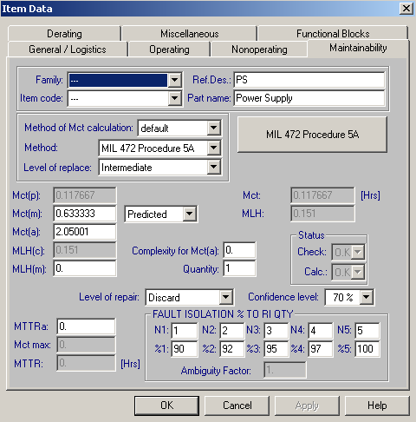

Reports available
The main maintainability reports available:
Maintenance Tasks Analysis (MTA) report provides a prediction of work load for each skill type and equipment, and material usage:
MTA: Information | Item, Maint.Task, required skills, equipment and materials for each task
MTA: Skills summary | Calculation of Total Labor Hours per year for each skill type, according to system usage scenario.
MTA: STE summary | Calculation of Total Labor Hours per year for each equipment type, according to system usage scenario.
MTA: Material summary | Calculation of material consumption for maintenance tasks per year for each material, according to system usage scenario.

Maintenance Engineering Analysis (MEA) — displaying the time period for each maintenance task and is used in Integrated Logistics Support
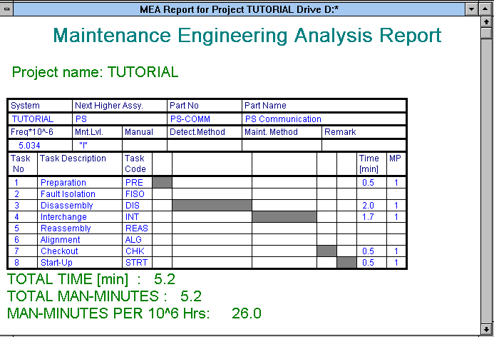

MSG-3

RAM Commander MSG-3 module is used by aircraft manufacturers or aircraft operators (airlines) to perform aircraft Scheduled Maintenance Development analysis according to Air Transport Association (ATA) Maintenance Steering Group 3 (MSG-3) document.

According to ATA, the ATA MSG-3 publication outlines a decision-logic process for determining initial scheduled maintenance requirements for new aircraft and/or power plants. This document presents a means for developing maintenance tasks and intervals acceptable to regulatory authorities, operators and manufacturers. The analysis has the objective to maintain an inherent safety level and to achieve an optimal balance between maintenance costs and reliability.

RAM Commander’s MSG-3 module main features:
- Intuitive step-by-step procedure
- Integration with Reliability and FMECA analysis modules
- Interactive decision diagrams
- Final report generation is MS Word
- Customizable MS Word report template

The MSG-3 module is integrated with RAM Commander Reliability and FMECA modules. It divides the procedure into 7 steps including system definition, maintenance significant items selection, failure effect categorization, task selection and development and report generation.

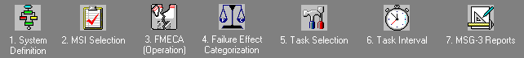

It brings user through the decision-making process using interactive decision diagrams taken from the standard:

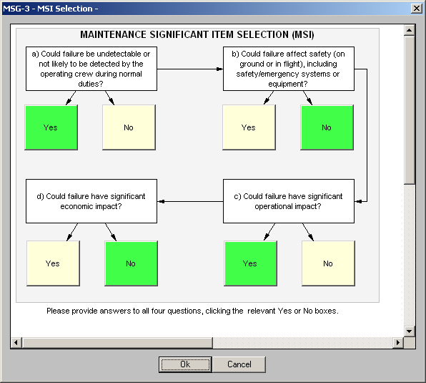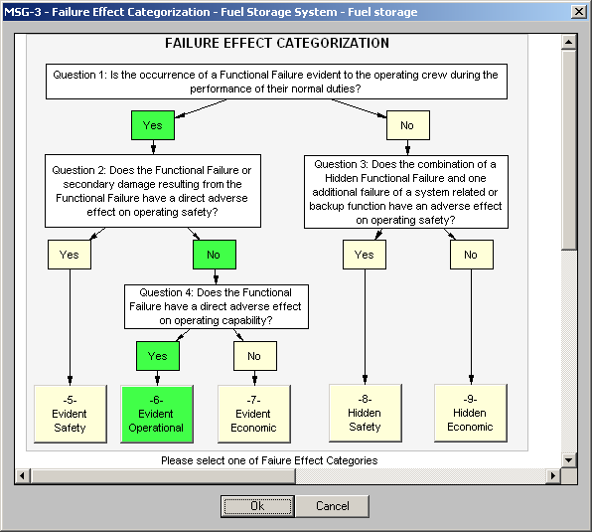

As an output of the procedure user gets final report generated in MS-Word with all the data inside. Report is generated based on customizable MS Word template; user may change the template design.
 | 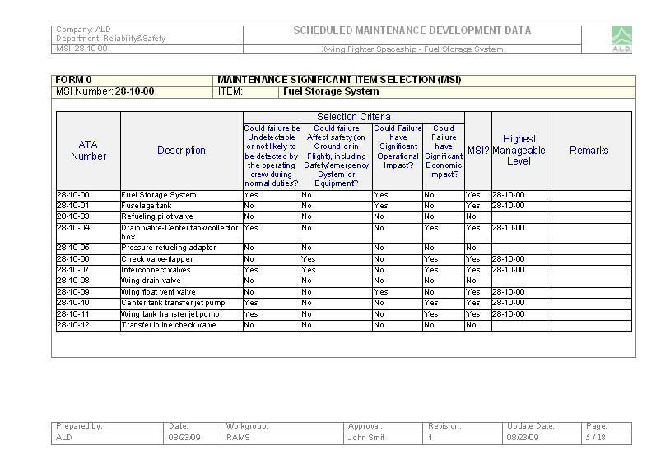
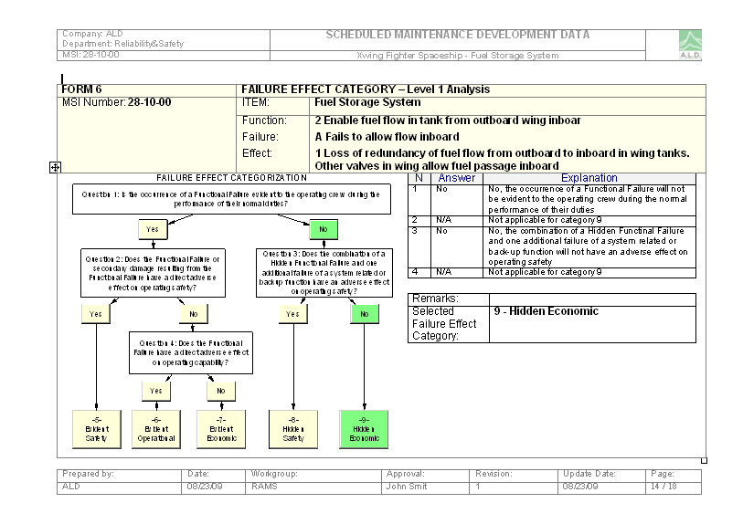 | 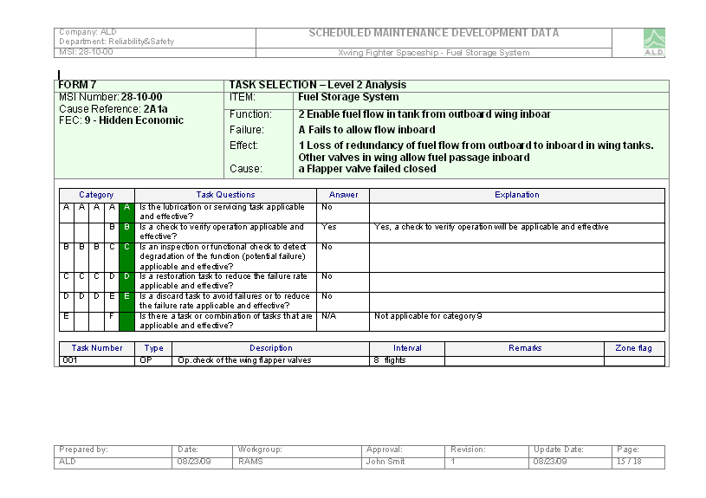

RCM
RCM (Reliability Centered Maintenance) module
RCM utilizes a systematic approach to understand how equipment fails, and what maintenance tasks can be done to minimize failures and maximize reliability. RCM also provides the foundation for understanding why certain maintenance tasks are performed and the justification for eliminating unnecessary Preventive Maintenance (PM) activities. It is the optimal mix between the Corrective, Preventive, and Condition-Based maintenance. RCM is a function-oriented approach which considers mission importance, environment, safety, security, economics and regulation requirements.
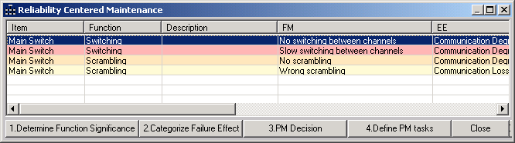
The RCM analysis process involves 7 main steps, each one of the steps is supported by the RCM module of RAM Commander:
- System definition (product tree, Functional blocks).
- Significant Functions identification:
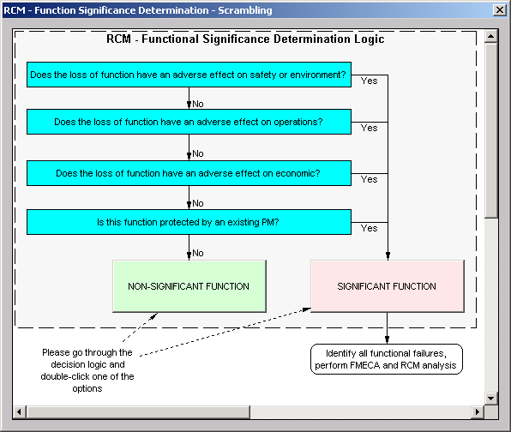
- FMECA analysis, Failure Effects Categorization:
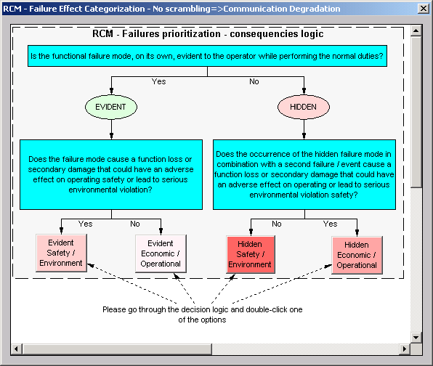
- Preventive Maintenance strategy decision:
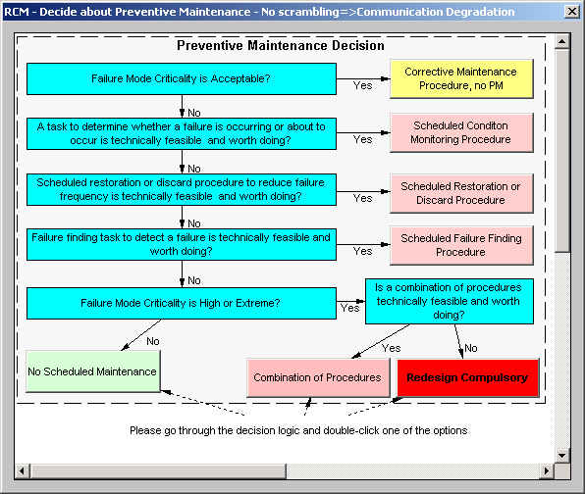
- Preventive Maintenance definition and frequency optimization:
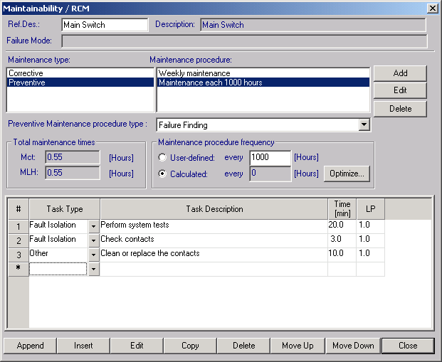

Component libraries
RAM Commander has an easy to use built-in libraries mechanism supporting the ability to utilize extensive component data of three kinds:
- RAM Commander Component Library (module LIB in the price list) containing thousands of widely used active parts by the world leading manufacturers continually updated by RAM Commander team adding more manufacturer’s data on a monthly basis.
- Powerful Decoding Mechanism for hundred of thousands passive components: Resistors and Capacitors. In order to activate Decoding for a specific component you need to know one of the following:
- Military Number
or
- Military Part Number
or
- Manufacturer Name & Manufacturer Part Name
- User-defined libraries created by a user;
Library search engine ensures additional time saving.
Active Component manufacturers
Actel  Alfa Microelectronics  Altera  AMD – Advanced Micro Device  Analog Devices  Atmel  AVX  Bourns  Broadeom  Cal – Chip Electronics  Cypress  Dallas Semiconductor  DDC  Elantec  Exar  Farchild  Fujitsu Microelectronics  Hitachi  HP  IDT  Infinion Technologies A6  Intel  Intergil  International Rectifier (IR)  Intersil  IRC  IXYS  Kemet  KOA Sper Electronics  Kyocera | Linear Tech  Maxim  Micrel  Micron  Microsemi  Mitsubishi  Molex  Motorola  Murata  National Semiconductor  NEC  ON Semiconductor  Pericom  Philips  PMD (Princeton Electronic Systems)  RF Micro Devices  RF Power Components  Samsung  Simpson  Sony  ST Microelectronics  Taiyo Yuden  Texas Instruments  Tomson  Vishay  Vitesse Semiconductor  Xicor  Xilinx  Yageo
For the detailed info on decoding of the Passive components, ask us for a corresponding document: RAM Commander Component Libraries
FMECA
Previously a separate software package, FMECA is now a fully integrated RAM Commander module. This module serves for automated Failure Mode, Effects and Criticality Analysis.
The FMECA is suitable for both hardware and functional approaches to FMECA, and fully complies with MIL-STD-1629 A, commercial standards, and Good Manufacturing Practice (GMP) requirements.
The FMECA Process
Utilizes the Product tree built for RAM analysis database. The branches of the tree are composed of items or functions.
Failure Modes and Effects - A failure mode is defined as the manner in which a component, subsystem, or system may fail to meet design intent. A failure mode (FM) could also be the cause of a failure mode in a higher level subsystem or system, or be the effect of a failure mode in a lower level component.
Failure Modes and NHE Processing - Building the FM and NHE tree is based on defining failure modes for every lowest level item in the product tree and the Next Higher Effects for each failure mode.
After you define a NHE for a FM, FMECA automatically creates a corresponding FM for the next higher level item. This means that assigning FMs for assemblies is done automatically by scanning the NHEs for next lower level items.
FMECA Reports – easily exported: FMEA; Criticality Analysis; Criticality Matrix Reports Group; Basic Fault Tree.
Features
Library driven - FMECA uses component, failure mode, end effect severity libraries.
Modular structure and customized configuration.
Full visibility of failure modes, next higher & end effects sequence.
Automatic calculation of failure mode and item Criticality Numbers, End Effect conditional probability, and other parameters for Criticality Analysis.
Reports
FMECA module reports provide the basis for safety analysis
FMEA
Criticality Analysis
Single Point Failure Mode List
Criticality Matrix Reports Group
Basic Fault Tree
  - Failure Modes by End Effect

FMECA Testability Analysis

Testability features are integrated into the FMECA module and are intended for in-depth Testability analysis. The main characteristics of Testability - BIT/ Detection Coverage and Fault Isolation Resolution - can be calculated for each maintenance level (Organizational, Intermediate, Depot) and for specific detection methods (BIT, BITE, external test equipment, etc.). Test method efficiency are defined for each Test method.
The main reports and analyses during Testability Analysis:
- BIT/Detection Coverage
- Fault Isolation Resolution
- Undetectable Failure Modes
- Testability Information
Testability analysis facilitates development of the necessary supporting documentation:
- Maintenance Manuals
- Troubleshooting procedures
- Quality Assurance inspection requirements
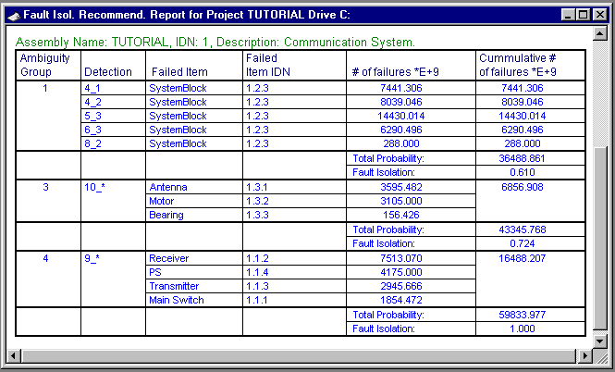

Isolation Tree Diagram – fault isolation visualization

Isolation Tree - a new, graphical report in Testability Analysis Module (TAM) turns this already powerful module into unbeatable tool for the visual presentation of the results of failure and testability analyses. The Isolation tree displays the results of failure and testability analyses as a graphically presented logical tree. Analyst has a freedom of manipulating the Isolation Tree to present all tests for the SUA and all failure effects of the SUA simultaneously or only selected tests and/or specific failure effect. Isolation Tree is a crucial tool for communication between reliability and design engineers and is extremely helpful for diagnostic/support personnel.

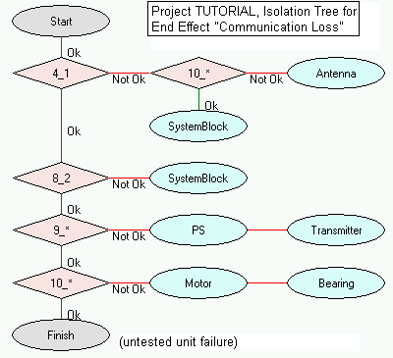

New field “Sequential Number” in FMECA Test Library
New field Sequential Number was added to FMECA Test Library. The field is a numeric field used for describing real testing sequence for the full system test. The sequence is used in building of an Isolation Tree report

Process & Design FMEA
Formerly a separate package, Process and Design FMEA is now fully integrated in RAM Commander. This module performs Process/Design potential Failure Mode and Effects Analysis based on MIL-STD-1629 Standard.
The P/D FMEA Process
- Stage 1: Building the Design/Process Flow with the help of built-in Visio-style Diagram Editor - Decompose the system or process into a flow of blocks or sub-processes. For each block in the flow, define all required parameters, such as name and item function. You can retrieve data from various external sources, such as the FMECA library.
- Stage 2: Failure Mode Causes and Effects - In this stage, failure modes, their causes and potential effects are entered by automatic loading from the failure mode and failure cause libraries, or by manual data entry. A potential failure mode is defined as the manner in which a component, subsystem, or system could potentially fail to meet the design intent. The potential failure mode could also be the cause of a potential failure mode in a higher level subsystem or system, or be the effect of a potential failure mode in a lower level component. Potential failure modes that could only occur under certain operating conditions, such as hot, cold, dry or dusty, weather should also be considered.
Potential effects of failure are defined as the effects of the failure mode on the function as perceived by the customer. Potential cause of failure is defined as an indication of design weakness, the consequence of which is the failure mode. The designer should assess occurrence and detection of each cause, as well as the severity of each end effect.
- Stage 3: Decision making – RAM Commander FMEA implements the unique, industry-proven decision making mechanism facilitating the choice of the most critical potential failure causes, manages FMEA team work on recommendations for possible corrective actions and give the clear guideline for evaluation of feasibility/efficiency of these actions.
- Stage 4: Reports - FMEA displays analytical results in a wide variety of tables and graphs. You can export these reports to other programs such as word processors or spreadsheets for customized analysis.
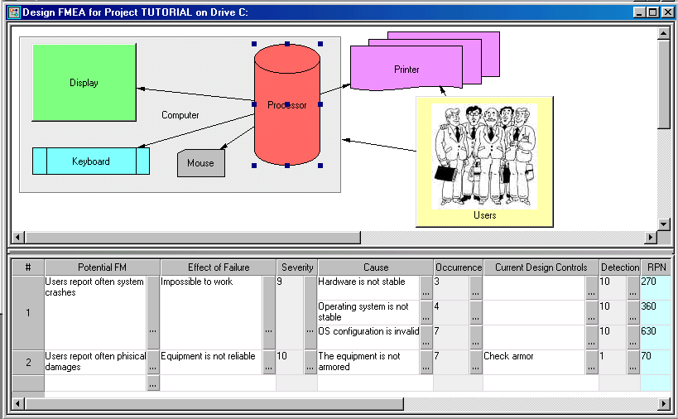
Features
- Graphically presents a flow of design/process FMEA allowing full visibility of process/design blocks
- Designed according to the Ford, GM and Chrysler (AIAG) specification and satisfies all requirements of QS-9000 for PFMEA
- Supports the concurrent updating of FMEA documents as new failures are discovered, as required by QS-9000
- Complies with most Safety and Hazards Analysis standards and regulations
- Assures that all critical potential failure modes and their causes have been isolated and corrected;
- Supports decision making and provides powerful mechanism for RPN reduction;
- Supports multi-criteria feasibility evaluation technique;
- Import/Export to MS Excel
Reports
- Design/Process FMEA according to the AIAG FMEA standard
- Pareto Analysis
- FMEA before and after decision making
- FMEA improvement statistics
- Criticality "Scree" Plot and tabular report
- Fault Tree Analysis (FTA)

Fault Tree Analysis (FTA)
RAM Commander’s FTA module is the latest addition to the unique scope of the RAM Commander features. It implements and summarizes the first-hand experience gained by the A.L.D. FTA experts in hundreds of projects where they used RAM Commander and other FTA software.
RAM Commander FTA is a powerful tool with the following features:
- Up-to-date, intuitive and powerful fault tree diagram interface with possibilities of full control over the diagram: elements location, colors, styles, zooms etc.
- Convenient ways of diagram printing and simple Copy & Paste transfer to other applications
- Easy to use and reusable Events Library
- Calculation of Unavailability, Mean Unavailability, and Minimal Cut Sets.
- Calculation of Importance and Sensitivity
- Calculation of Frequency, Intensity, Uncertainty ( release 2004)
- Set of required reports – tree, tree diagram, events library, MCS etc.
- Connection between FTA and product tree
- Connection between FTA and FMECA
- Automatic creation of the fault tree from FMECA (release 2004)
- Automatic creation of the fault tree from RBD (release 2004)
- Unique graphical FTA Unavailability Improvement by regulation of basic events parameters (release 2004)
FTA basics
Fault Trees are one of the most widely used methods in system reliability and failure probability analysis. A Fault Tree is a graphical representation of events in a hierarchical, tree-like structure. It is used to determine various combinations of hardware, software, and human error failures that could result in a specified risk or system failure. System failures are often referred to as top events. A deductive analysis using a Fault Tree begins with a general conclusion or hazard, which is displayed at the top of a hierarchical tree. This deductive analysis is the final event in a sequence of events for which the Fault Tree is used to determine if a failure will occur or, alternatively, can be used to stop the failure from occurring. The remainder of the Fault Tree represents parallel and sequential events that potentially could cause the conclusion or hazard to occur and the probability of this conclusion.
A fault tree is a graphical representation of a logical structure representing undesired events ("failures") and their causes. You create the logical structure by using gates and represent undesired events by using basic events. Reliability parameters are assigned to the basic events. Widely used in system reliability studies, fault tree analysis offers the ability to focus on an event of importance, such as a highly critical safety issue, and work to minimize its occurrence or consequence. The probability of the top-level event can then be determined by using mathematical techniques. The resulting fault tree diagram is a graphical representation of the chain of events in your system or process, built using events and logical gate configurations.
Fault Trees are composed of events and logical event connectors (OR-gates, AND-gates, etc.). Each event node's sub-events (or children) are the necessary pre-conditions that could cause this event to occur. These conditions can be combined in any number of ways using logical gates. Events in a Fault Tree are continually expanded until sub-events are created for which you can assign a probability. Events in a Fault Tree describe the different levels of system abstraction. Higher nodes represent a high level of abstraction while lower nodes represent a low level of abstraction.
The main purpose of Fault Tree Analysis is to evaluate the probability of the top event using state-of-the-art analytical and/or statistical methods. These calculations involve system quantitative reliability and maintainability data, such as failure probability, failure rate, expected failure, down time, repair rate, etc.
Two types of analysis can be conducted using Fault Trees:
- Qualitative analysis: performed by means of Minimal Cut Sets (MCS) building
- Quantitative Analysis: it is Calculation of Absolute probabilities, i.e. probabilities of system failures
Definition: A Cut Set is a collection of basic events that if all its events occur, the fault trees top event is guaranteed to occur.
The following FTA elements are used and supported in the RAM Commander software:
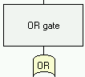 | OR gate - output event occurs if any of the input events occurs.
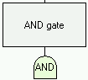 | AND gate - output event occurs only when all the input events occurs simultaneously.
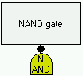 | NAND gate – NOT AND operation
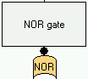 | NOR gate – NOT OR operation
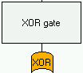 | XOR gate – Exclusive OR operation
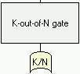 | K-out-of-N gate - output event occurs if K or more of the input events occurs
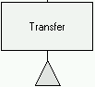 | Transfer gate – transfer to another tree (sub-tree)
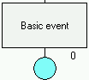 | Basic event - represents a basic equipment fault or failure that requires no further development into more basic faults or failures.
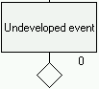 | Undeveloped event - represents a fault event that is not examined further because information is unavailable or because its consequence is insignificant.
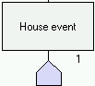 | House event – represents a condition or an event which is TRUE (ON) or FALSE (OFF) (false).
In addition, NOT operation could be performed to gates and events.
Diagram may also contain unlimited number of free-positioned remark boxes.
Reports
The FTA module offers the following reports:
- Minimal Cut Sets
- Tree diagram
- Basic events
- Tree output
- Importance / Sensitivity Analysis

Safety

RAM Commander’s Safety module is the latest addition to the unique scope of the RAM Commander features. It implements and summarizes the first-hand experience gained by the A.L.D. experts in hundreds of projects.

RAM Commander Safety Module is planned to evolve into a comprehensive safety toolkit implementing safety tasks defined in the various the safety assessment standards/guidelines. The first release of RAM Commander Safety module implements the requirements and tasks of SAE APR4761.

IEC 61508 - Safety Standard for Safety Instrumented Systems.
This standard involves a systematic approach to Life Cycle Safety of Safety Instrumented Systems (SIS). Systems such as these need to be maintained to be sure of a certain safety level during operation. It is concerned specifically with Electrical/Electronic/Programmable Electronic Safety-Related Systems (E/E/PESs).
IEC 61508 provides guidelines to classify these systems by Safety Integrity Levels (SIL levels).

The safety assessment process has fundamental importance in establishing appropriate safety objectives for the System Under Analysis (SUA) and determining that the implementation satisfies these objectives. The safety assessment process is iterative by nature; using RAM Commander to support all necessary iterations and to produce all required output is the easy, accurate and time-saving way to do the safety assessment. RAM Commander Safety Module implements tasks of qualitative and quantitative safety assessment required during system development:
- Generation and verification of safety requirements;
- Identification of all relevant failure conditions;
- Consideration of all significant combinations of failures causing failure conditions;
- Generation of output reports starting from the stage of Functional Hazard Analysis (FHA/ PHA) and ending by the System Safety Assessment (SSA) and Safety Assessment Results Summary verifying that the design meets safety requirements;

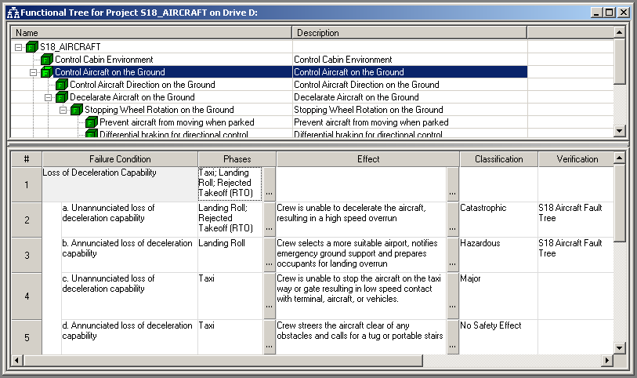
RAM Commander's easy-to-use modules: Reliability Prediction, RBD, FMECA and FTA are the basis and the heart of the Safety Module.

Module usage scenario includes functional tree building, specification of all possible failure conditions (including relevant mission phase, severity, end effect etc.) and comprehensive FHA reports generation.
For quantitive analysis we provide probability calculation for each failure condition, using RBD, FTA or Markov module. Usually FTA diagrams are used. Each failure condition is linked to corresponding Fault Tree which calculation provides failure condition probability:

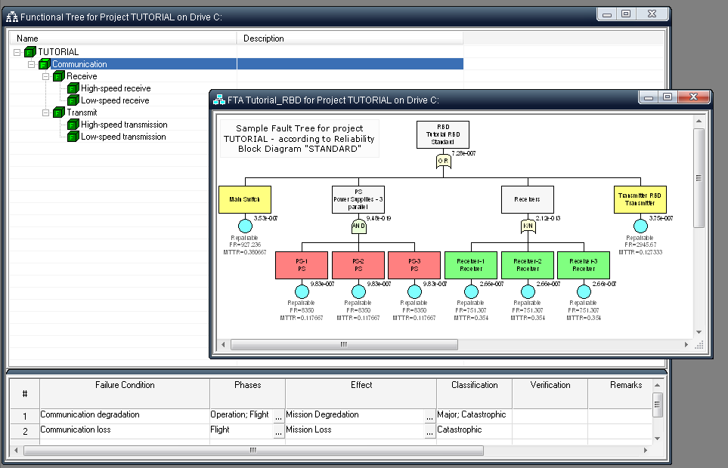

Final SSA Summary results report shows expected and desired probabilities for all failure conditions, and there we may check that probabilities of all failures are lower than required by safety regulations and design objectives.

Master Minimum Equipment List (MMEL)

The Master Minimum Equipment List (MMEL) is a document which lists the equipment that may temporarily be inoperative, subject to certain conditions, whilst maintaining an acceptable level of safety as intended in the applicable documents. Each MMEL document is specific to an aircraft type.

MMEL analysis is required for all aircraft manufacturers to certify aircraft safety in different aviation authorities such as FAA, EASA etc.

RAM Commander integrated MMEL module supports Master Minimum Equipment List generation using Reliability, FMECA, FHA and FTA modules results.

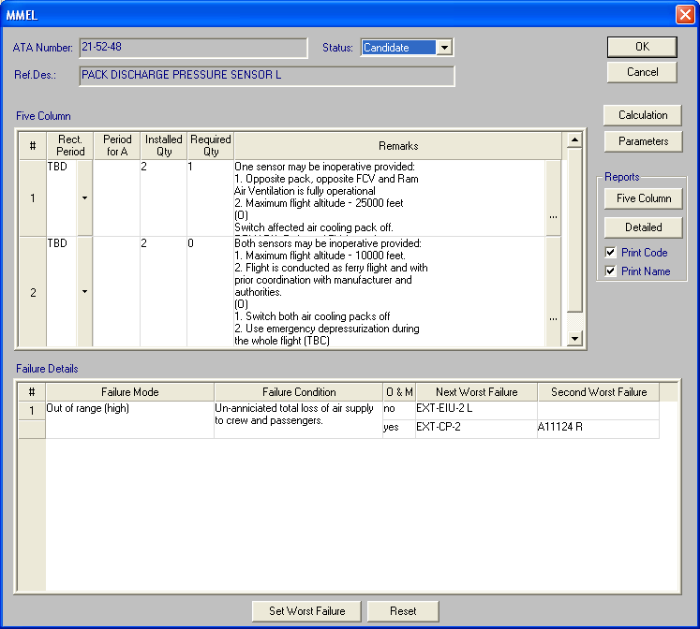

RAM Commander’s MMEL module main features:
- Compliance with MMEL requirements
- Integration with aircraft Reliability and Safety analyses modules
- Candidate Item selection
- Calculation(s) of Expected Probability before and after failure
- Automatic identification of the next (first in flight) and second worst failures
- Reports generation:
  - Standard MMEL: “Five Column Format” – presents the standard MMEL report
  - Detailed Quantitative Analysis – presents results of analysis on which MMEL selection has been made

MMEL module provides several algorithms for MMEL candidate selection:
- Algorithm based on JAA MMEL development guidelines
- Algorithm implementing RRJ – 95/75 guidelines
User may select appropriate algorithm for system analysis.

Below is the example of standard MMEL 5-column report as generated by RAM Commander:

ATA Chapter: AIR CONDITIONING |  |  |  |  | PAGE: 21-01
(1) System & Sequence Numbers | (2) | Rectification Interval
 |  | (3) | Number Installed
 |  |  | (4) | Number required for dispatch
ITEM |  |  |  | (5) Remarks or Exceptions
ATA
21-52-48 | TBD | 2 | 1 | One sensor may be inoperative provided:
PACK DISCHARGE PRESSURE SENSOR L |  |  |  | 1. Opposite pack, opposite FCV and Ram
 |  |  |  | Air Ventilation is fully operational
 |  |  |  | 2. Maximum flight altitude – 25000 feet
 |  |  |  | (О)
 |  |  |  | Switch affected air cooling pack off.
 |  |  |  | REMARK: Refer to AFM for performance
 |  |  |  | limitations (TBC)
 |  |  |  | (М)
 |  |  |  | 1. Deactivate affected air conditioning pack.
 |  |  |  | 2. Install INOP placard for affected air cooling packs controls (TBC)
 | TBD | 2 | 0 | Both sensors may be inoperative provided:
 |  |  |  | 1. Maximum flight altitude – 10000 feet.
 |  |  |  | 2. Flight is conducted as ferry flight and with prior coordination with manufacturer and authorities.
 |  |  |  | (О)
 |  |  |  | 1. Switch both air cooling packs off
 |  |  |  | 2. Use emergency depressurization during the whole flight (TBC)
 |  |  |  | 3. Do not use recirculation system (TBC)
 |  |  |  | REMARK: Refer to AFM for performance limitations (TBC)
 |  |  |  | (М)
 |  |  |  | 1. Secure ram air valve in open position.
 |  |  |  | 2. Install INOP placard for recirculation system controls (TBC)
 |  |  |  | 3. Install INOP placard for both air cooling packs controls (TBC)

Event Tree Analysis Module

An event tree analysis (ETA) is an inductive procedure that shows all possible outcomes resulting from an accidental (initiating) event, taking into account whether installed safety barriers are functioning or not, and additional events and factors.

By studying all relevant accidental events (that have been identified by a preliminary hazard analysis, a HAZOP, or some other technique), the ETA can be used to identify all potential accident scenarios and sequences in a complex system.

Design and procedural weaknesses can be identified, and probabilities of the various outcomes from an accidental event can be determined.

RAM Commander ETA Module features:
- User-friendly and convenient tree building interface
- Customizable graphical presentation – diagram colors, styles, positions, remarks, pictures etc.
- Events Library
- Event Probability assessment models:
  - user-defined
  - calculated (repairable/unrepairable/constatnt mission time/periodical tests)
  - linked to product tree element
  - linked to FMECA Failure Mode, NHE or End Effect
  - linked to Fault Tree basic event
  - linked to Fault Tree gate or tree top event
- Various Event logic types:
  - Binary logic
    - True/False
    - Success/Failure
  - Multiple alternatives (for events where not only True/False or Success/Failure outcomes are considered)
- Different Event probability types
  - Equal event probabilities in all sequences
  - Different event probabilities in different sequences (conditional probabilities)
- Multiple outcomes for single sequence
- Outcome severity parameter
- Calculation
  - Outcome (consequence) probability calculation
  - Minimal Cut Sets calculation for each outcome (or specific severity) and outcome probability calculation (usefull if different sequences lead to the same outcome)
  - Importance and Sensitivity calculation for Outcome or Severity
- Printing
  - Diagram
  - Outcome probabilities and sequences
  - MCS calculation report
  - Importance and Sensitivity report
- Diagram export to Clipboard as vector graphics object (EMF)
- Zoom in/Zoom out
Automatic tree rebuild / rearrange with possibility to manually change elements positions

D-LCC

D-LCC - Software for Decision
by Life Cycle Costing

The D-LCC Process
- System Setup - Setup includes the Alternatives and Period tables, and optional part product tree.
- Global Variables - cost elements that indirectly impact the cost breakdown structure
- Cost breakdown structure - Construct a tree representation of all cost elements
- Formulas - formulas for evaluating the cost of all elements in the cost breakdowns structure
- Output Reports - D-LCC generates a wide variety of reports, both in tabular and graph form.

Features
Cost Profile Analysis - D-LCC supports detailed examination of dynamics of future cash flows over multiple time periods.

Sensitivity Analysis - The Sensitivity Analysis option in D-LCC computes changes in the model’s output according to changes in any global variable. This technique identifies major cost drivers (Pareto “vital few”), supports trade-off analysis and indicates the effect of altering critical parameters and assumptions.

Net Present Cost (NPC) - In financial and budgetary analysis, a necessary requirement is to identify the present value of future cash flows called Net Present Cost. The NPC analysis also provides comparison of options with different inflation and discount rates.

Cost-Effectiveness evaluation - Managers are interested in cost-effectiveness which is typically calculated in terms of performance per unit cost.

Cost Projection analysis - D-LCC provides a utility to calculate the costs of a particular budget line item. This “Cost Item” function computes the contribution of any item, such as labor, or material. Results are reported at the element level and rolled up into a project total.

Product Tree Cost Calculation option allows for incorporating the Product Tree parameters in LCC model and calculating any required cost elements (like spare parts cost for each Level of Repair) across all Product Tree items.

Reports
- Total and Detailed Costs
- Cost Profile
- Cost Profile by Elements
- Cost-Effectiveness
- Basic CBS Tree
- Versatile User-definable Graphs and Tables

FavoWeb

FavoWeb – Web-based Dynamic FRACAS

A long awaited new generation Failure Reporting and Analysis System (FRACAS) provides all answers for any organization which designs, manufactures, operates and maintains complex equipment and looks for the up-to-date and efficient way to collect, analyze, process and access the failure/malfunction/event data
FavoWeb™ - the Failure Reporting and Analysis software developed by the ALD. FavoWeb™ summarizes 18 years of ALD’s FRACAS development experience for the FRACAS customers around the world.
FavoWeb™ is the failure/event reporting and processing software for any phase of a product/service life cycle in the wide range of industries.
FavoWeb™ makes the adaptation to any phase (design, manufacturing, O&M, etc) and industry (aircraft, defense, telecommunication, home appliances, etc) easy and logical.
FavoWeb™ introduces the “cutting edge” technologies – World Wide Web and Intranet to a failure/event reporting system – no need in the endless forms and Excel sheets -. the collected data is accessible throughout organization/industry/world
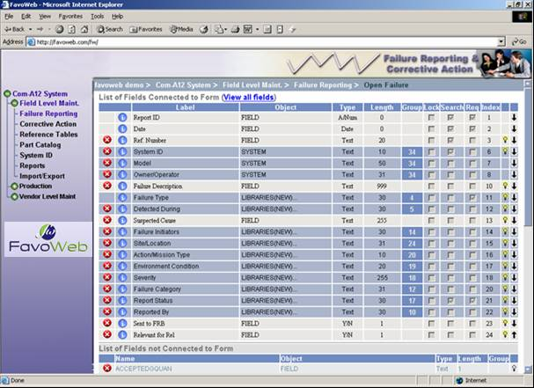

FavoWeb™ Design Ensures:
- Applicability to any phase of a product life cycle: from design to maintenance
- Applicability to the wide range of industries
- Easy Setup and Adaptation
- Customer-tailored data fields and functions
- Intranet / Internet accessibility
- Combination of easy data collection with on-line visibility for on-line analysis
FavoWeb™ Functionality:

- Failure/Event Data Collection
- Test Results Recording
- Data Analysis According to the User-defined Criteria
- Corrective Actions Recommendation and Analysis
- Calculations & Statistics: MTBF, MTBCF, MTTR, MTBMA, MDT, Availability
- Output Reports
- System Administration
- Full World Wide Web and Intranet Capabilities
- Data Security
- Export/Import – MS Access, Excel, HTML, Oracle, Text, ASCII
- Export field MTBFs to RAM Commander
- Voice Recognition (optional)
- Customer Complaints and Satisfaction (optional)

FavoWeb™ Modules

Description | Module Name
- Failure/Event Reporting  - Product Tree  - Libraries  - Administration Module  - Corrective Actions  - 2 Basic report generators (Failure distribution; Failure list) | Application Server - Basic Configuration
Choice of 5 advanced statistical reports based on the latest techniques used in the industry. | Extended Reports Set
Scheduled maintenance based on RCM approach; | Scheduled Maintenance
Tracking system/sub-system history and configuration by serial number | Systems/SN Traceability
Automatic notification and alerts system for the failure processing; | Alerts Module
Graphic Presentation tool for failure Trend Analysis, Failure distribution/Pareto and correlation | Dashboard
Analysis of main drivers of warranty claims based on Wiebull analysis. | Warranty Module
Quality System Management for planning and performing of Quality Activities. Based on ISO 9000 requirements. | FavoScope
Data collection from suppliers report stations. Provides statistical Reports about supplier rating and performance. Based on ISO/TS 16949 requirements | Suppliers Management Module

FavoWeb™ saves the unjustified expense of the in-house FRACAS development.

FavoWeb™ answers all your organization’s needs and will help to avoid the pitfalls of the old generation FRACAS.

FavoWeb Dashboard

- Flexible management reports view
- Alerting mechanism
- One look general view
- OLAP methodology
- Self customized module
- Implemented on NET. platform (no ActiveX)

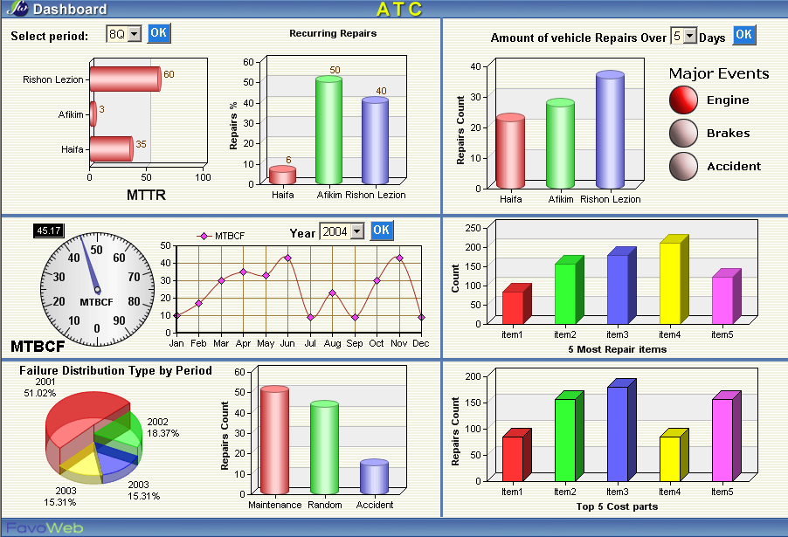

Voice Recognition

Increased Reported Events:
  - Easy & Quick
  - Available
  - Motivating
Increased Reliability of Reported Event:
  - Real Time Reporting
  - Updatable Taxonomy
  - Recording Feature for Future Reporting
Increase Technicians Safety:
  - Hands free Reporting
Multilingual System:
  - Support all Languages

